WP 1 – Review and analyze best EU and global practices in cloud computing

DEV 1.1 –Existing EU and global practices for cloud based solutions

Authors:
Prof.dr Ramo Šendelj, UDG
Assist.Prof.dr Ivana Ognjanović, UDG

Table of Contents
1. Introduction 3
2. Cloud Computing Trends 4
3. Cloud computing adoption - industry specific perspective 5
4. Referenced studies on cloud adoption – industry specific benchmark … 6
5. Conclusion 7

Introduction

The purpose of this report is to provide research among best practices of using cloud computing among different EU and global countries. It will also include review of cloud trends in key EU industries (healthcare, banking, retail, media, education, governments, etc.), as well as review of referenced studies on cloud adoption – industry specific benchmarks. Besides that, it can also be used by cloud computing users who are looking for more information about applications, services and infrastructure, with scalable and flexible attributes that can be deployed through self-service. The consortium has defined a framework around cloud technologies and support mechanisms or context enablers to foster cloud adoption in the EU market. The report covers benchmark activity done in the following areas:

Technology: products and services within IaaS, PaaS, and SaaS segments focusing technology and business enablers such as marketing strategies; business models, etc. This report also studies reference European funded Cloud computing research in order to identify ready-to-market outcomes.

Supporting instruments: policies - ICT & Cloud computing policies on local and EU level, accelerator and incubators.

The main objective of the report is to gather key cloud computing trends throughout Europe within targeted countries Portugal, Spain, Slovenia, Germany, Poland, France, UK and to identify enablers for Cloud innovation, by the analysis and compilation of major Cloud trends in European industries, with high potential to become heavy users of cloud services (ICT, education, banking, healthcare, media, and government).

Cloud Computing Trends

The world is witnessing a dramatic increase in the amount and variety of data being produced. Alongside the data created by billions of people using digital devices and services for personal and professional reasons, and the data generated by the increasing number of connected objects, there is data from research, from digitized literature & archives and from public services such as hospitals and land registries. This "Big Data" phenomenon creates new possibilities to share knowledge, to carry out research and to develop and implement public policies.

It is also becoming easier to exploit this data thanks to the Cloud. The Cloud can be understood as the combination of three interdependent elements: the data infrastructures which store and manage data; the high-bandwidth networks which transport data; and the ever more powerful computers which can be used to process the data. The ability to analyze and exploit this Big Data is having an impact on the global economy and society, opening up the possibility of major industrial and social innovations. A key part of this impact is the change in the way scientific research is carried out, as we move rapidly towards.

Cloud computing is internet-based computing, where shared servers provide computing power, storage, development platforms or software to computers and other devices on demand. This frequently takes the form of cloud services, such as ‘Infrastructure as a Service’ (IaaS), ‘Platform as a Service (PaaS)’ or ‘Software as a Service’ (SaaS). Users can access web-based tools or applications through a web browser or via a cloud-based resource like storage or computer power as if they were installed locally, eliminating the need to install and run the application on the customer’s own computers and simplifying maintenance and support. There are several possible deployment models for clouds, the most important being public, private and hybrid. The Cloud makes it possible to move, share and re-use data seamlessly across global markets and borders, and among institutions and research disciplines. With the current capacity available in Europe, the data produced by EU research and industry is often processed elsewhere and European researchers and innovators tend to move to the places where high data and computing capacity is more immediately available. At the same time, as Europe is the largest producer of scientific knowledge in the world, it is well placed to take the global lead in the developing of a science cloud.

Trends in cloud services: SaaS, PaaS and IaaS

European adoption of software as a service (SaaS), platform as a service (PaaS), and infrastructure as a service (IaaS) is growing strongly. The best indicator of its growth is the increase in usage and the fact that many European companies are developing their own services and capturing market share, though there is a strong competition from US vendors in most of the product categories. This chapter includes comparing different European cloud products to give enough information to complete understanding of cloud computing.

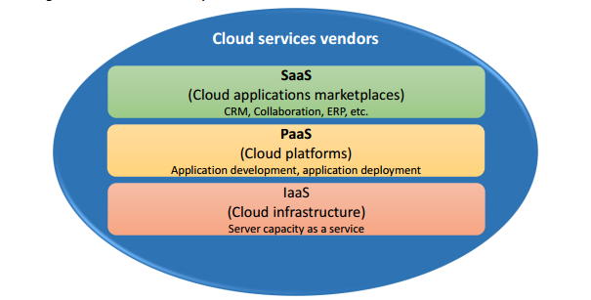
Figure 1. Coverage of cloud services analyzed

    - Infrastructure as a Service (IaaS)

The capability provided to the consumer is to provision processing, storage, networks, and other fundamental computing resources where the consumer is able to deploy and run arbitrary software, which can include operating systems and applications. The consumer does not manage or control the underlying cloud infrastructure but has control over operating systems, storage, and deployed applications; and possibly limited control of select networking components (e.g., host firewalls).

Platform as a service (PaaS)

The capability provided to the consumer is to deploy onto the cloud infrastructure consumer-created or acquired applications created using programming languages, libraries, services, and tools supported by the provider. The consumer does not manage or control the underlying cloud infrastructure including network, servers, operating systems, or storage, but has control over the deployed applications and possibly configuration settings for the application-hosting environment
    - Software as a service (SaaS)

The capability provided to the consumer is to use the provider’s applications running on a cloud infrastructure. The applications are accessible from various client devices through either a thin client interface, such as a web browser (e.g., web-based email), or a program interface. The consumer does not manage or control the underlying cloud infrastructure including network, servers, operating systems, storage, or even individual application capabilities, with the possible exception of limited user-specific application configuration settings.

Cloud computing - statistics on the use by enterprises

Main statistical findings

Use of cloud computing:

highlights 19 % of EU enterprises used cloud computing in 2014, mostly for hosting their e-mail systems and storing files in electronic form.

46 % of those firms used advanced cloud services relating to financial and accounting software applications, customer relationship management or to the use of computing power to run business applications.

In 2014, almost twice as many firms used public cloud servers (12 %) as private cloud servers (7 %), i.e. infrastructure for their exclusive use.

Four out of ten enterprises (39 %) using the cloud reported the risk of a security breach as the main limiting factor in the use of cloud computing services.

A similar proportion (42 %) of those not using the cloud reported insufficient knowledge of cloud computing as the main factor that prevented them from using it.

Cloud computing as a service model for meeting enterprises’ ICT needs

Essentially, instead of building their own IT infrastructure (which would include hardware and involve developing and maintaining software applications and databases), enterprises can access computing resources hosted by third parties on the internet (the ‘cloud’). In technological terms, cloud computing is a model for providing enterprises with ubiquitous, flexible, on demand access over the internet to a shared pool of configurable computing resources, including servers, databases, software applications, storage capacity and computing power.

Cloud computing can be seen as the technological evolution of server-based computing. The cloud/internet functions as an enormous networked server. Consequently, enterprises can use the services by accessing the internet using devices ranging from relatively low-cost desktop computers (‘thin clients’) to any number of various portable devices. Cloud computing services should be delivered from service providers’ servers and, for the purposes of the ICT usage and e-commerce in enterprises survey, have the following mandatory characteristics:

on-demand self-service: users may request computing resources without human interaction with the service provider;

elasticity of provision: capabilities may be easily scaled up or down, e.g. in response to changes in the number of users or required storage capacity, so that enterprises can meet demand peaks without having to invest in infrastructure that will otherwise remain idle or underutilised; and

payable services (pay-per-user, pay-per-use or pre-paid). In principle, the service providers may deliver ICT-related services from shared servers (public cloud) or from a cloud infrastructure provided for the exclusive use of a particular enterprise (private cloud).

Enterprises using cloud computing

As cloud computing services can be delivered only via the internet, enterprises must have internet access to be able to use them. In 2014, this applied to almost all EU enterprises (97 %) with 10 or more persons employed. Although the proportion of firms with internet access was at similar near saturation levels in most Member States, only one in five (19 %) reported that they used cloud computing services (see Figure 2).

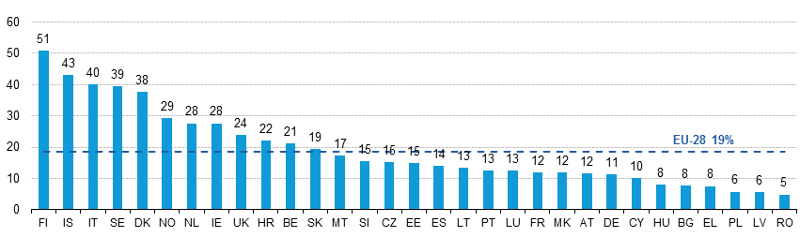
Figure 2. Use of cloud computing services by country

Significant differences can be observed across countries. In Finland, Iceland, Italy, Sweden and Denmark, over 30 % of enterprises used cloud computing. On the other hand, fewer than 10 % did so in Hungary, Bulgaria, Greece, Poland, Latvia and Romania. Of the enterprises that reported using cloud computing, some 66 % relied on a cloud solution for their e-mail (see Table 1). Instead of setting up a server infrastructure for their e-mail system, which would have involved inter alia capital expenditure and maintenance costs, these firms opted for a cloud solution based on per-user operating costs.

Cloud computing services may meet a wide range of other business ICT needs. Over half of all enterprises (53 %) used the cloud for storing files in electronic form. Some 39 % used it to host their database, while 34 % reported using it for office software (e.g. word processors, spreadsheets, etc.). Most importantly, via the cloud, enterprises access relatively more advanced end customer software applications, e.g. for finances/accounting and managing information about their customers (customer relationship management – CRM) (31 % and 21 % respectively). In addition, 17 % reported using the (usually high-performance) cloud computing platforms for computing power in order to run their own business software applications. Not surprisingly, the highest proportion of enterprises using cloud computing services (45 %) was in the information and communication sector, while in almost all other economic sectors the percentage ranged from 14 % to 20 % (see Figure 3). ‘Professional, scientific and technical’ firms came in between, with 27 % reporting that they used the cloud.
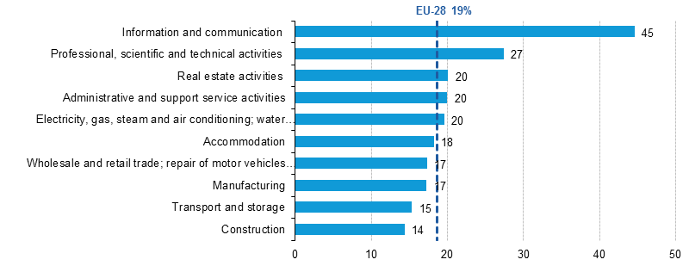
Figure 2. Use of cloud computing services

Enterprises’ dependence on cloud computing As regards dependence on cloud computing services, enterprises can be classified according to three levels (lower-medium, upper-medium and high) by combining the reported use of services as shown in the following table:
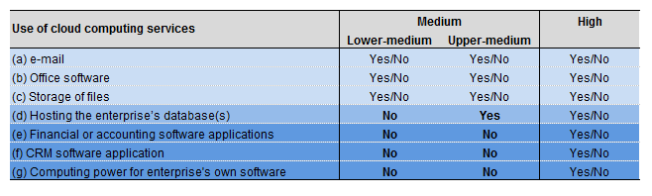
Figure 4. Use of cloud computing services

For this classification, all possible individual responses (in bold) are necessary conditions. For example, enterprises classified in the ‘lower-medium’ level will have reported using at least one of the services in (a), (b) or (c), but none of the others. Those classified in the ‘upper-medium’ level will, in addition, have reported using the cloud for (d), but none of the relatively advanced services in (e), (f) and (g). Enterprises classified in the ‘high’ level will have responded in the affirmative for at least one of the services in (e), (f) or (g).

19 % of EU enterprises reported using the cloud (see above) and a relatively high proportion (9 % of the total) reported using at least one of the advanced services ((e), (f) or (g)) and were hence classified as highly dependent (see Figure 5).
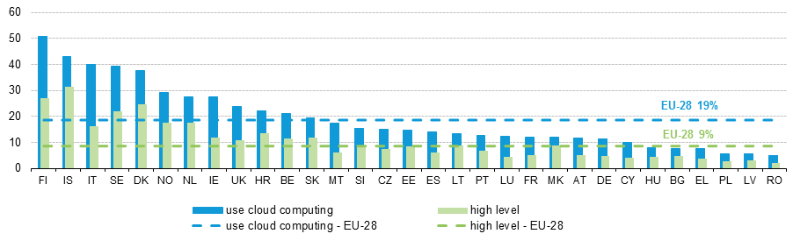Figure 5 .Enterprises with high level of dependence on cloud computing services, 2014 (% of enterprises)

Accordingly, 46 % of enterprises in the EU that used cloud computing were ‘highly dependent’, while 49 % used none of the advanced services and were classified in the ‘medium’ level (see Figure 6). At the two extremes, the majority of enterprises in the manufacturing sector (58 %) belonged to the medium-dependence group, while the majority in information and communication (63 %) reported using advanced services and hence belonged to the high-dependence group.

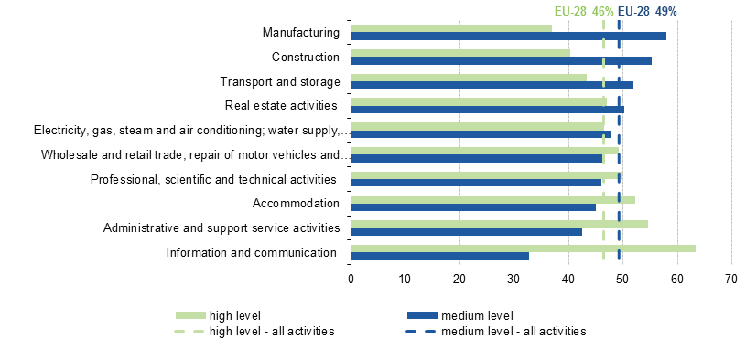

Figure 6. Degree of dependence on cloud computing, by economic activity, EU-28, 2014 (% of enterprises using the cloud)

Types of cloud computing: public and private cloud

Service providers can deliver cloud computing services with all the above characteristics in two main ways: via public cloud servers (12 % of enterprises) or private cloud servers (7 % of enterprises). The latter, by definition, involve a single-tenant environment where the hardware, storage and network are set aside for a single enterprise. Consequently, the infrastructure guarantees high levels of security, as the service provider’s other clients cannot access the same resources. Some 7 % of SMEs and 17 % of large enterprises reported using private cloud (see Figure 7).

In contrast, public cloud infrastructures are provided for shared use by multiple clients. Essentially, they tend to be highly standardised, with limited customisation options, e.g. an e-mail server can provide many firms with the necessary cloud infrastructure to manage their e-mail systems. Public cloud computing is reportedly used by 24 % of large enterprises and 12 % of SMEs in the EU.

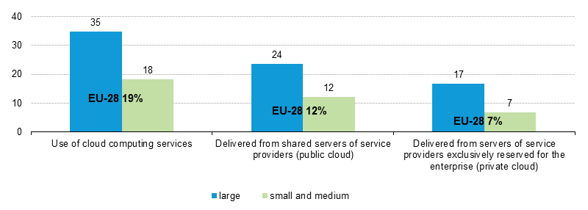

Figure 7. Use of public or private cloud, by size class, EU-28, 2014 (% of enterprises)

- Cloud computing adoption - industry specific perspective
  - Key Industries

Cloud computing offers many possibilities and benefits for enterprises in all industries. However, the following industries have been recognized as being the ones with highest potential to gain more from adopting the cloud: education, marketing, online entertainment, healthcare, IT, finance and banking, telecommunication, hospitality - accommodation industry, start-ups and security. The following methodology has been used in this chapter to cloud computing usage in respective industries:

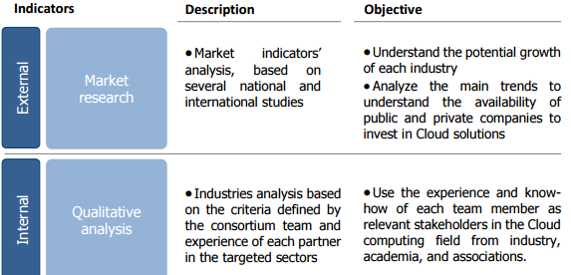

Figure 8. Methodology for cloud computing adoption analysis among various industries

Adoption of cloud computing varies among enterprises of different size in different industries: According to Gartner research, cloud computing can be adopted in five different levels: lagging, measured, moderate, heavy and advanced. The most advanced usage of cloud computing has been achieved in media industry. Media enterprises are using cloud computing services mostly for content management, content distribution and analytics. Second most advanced industry is education, with moderate level of cloud computing adoption. Cloud computing in education industry has been mainly used for email services, collaborative SW and back-office applications in a means of SaaS and IaaS. Third most developed industries concerning cloud computing adoption are banking, insurance and government. Enterprises in banking use mainly private cloud for SaaS for email, file sharing and sharing of notes in addition to some of IaaS. Enterprises in insurance use mainly noncore applications and limited SaaS for industry specific solutions. In government, enterprises mainly use private cloud for email and some other noncore applications. Fourth group with measured level of cloud computing adoption consist of enterprises in the following industries: energy and utilities, healthcare payers, healthcare providers, manufacturing and retail. Enterprises in energy and utilities industry are using cloud computing mainly as a delivery model for consumption data and billing or managing asset related GIS data. Healthcare industry is divided into healthcare payers and healthcare providers. Concerning healthcare payers, cloud computing is mainly used for administration and care transformation, while in healthcare providers for collaboration, imaging and medical records. In general, in healthcare cloud computing is used for claims processing, care management applications, medical records and medical image archives.

In manufacturing industry enterprises are mainly using cloud computing for SaaS as for example product development, life cycle management and some key manufacturing operations. In addition, cloud services are used for logistics, sales support functions and human resource management. In retail enterprises are using cloud computing for all 3 levels of cloud computing services – IaaS for on-demand data centers used as development and testing environments, PaaS for e-commerce applications and SaaS for various back-office and business applications.

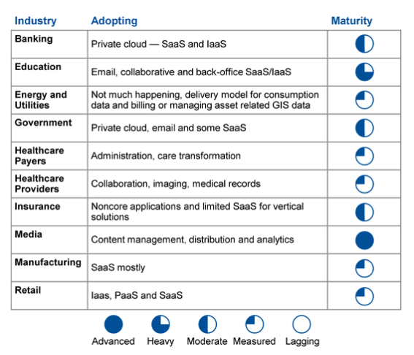

Figure 7: Industry use of cloud computing

Healthcare

HIMSS Analytics’ survey results show that 37,1% of organizations use private cloud, similar percentage of organizations use hybrid cloud computing model (36,3%). Public cloud is used by 23,4% of respondent healthcare organizations. 43’6% of respondents reported that their healthcare organizations use cloud services for hosting of clinical applications and data. This is followed by usage of cloud services for health information exchange (38,7%) and backups and disaster recovery (35,1%). In the future it is expected to use cloud services for hosting of archived data (38,9%), backups and disaster recovery (31,1%) and hosting operational applications and data (28,4%). Cloud services were least likely used for timely provisioning or deprovisioning accounts (91%), identity management (89,9%) and virtual networks (85,1%). Details of current areas of cloud applications in healthcare industry are presented in the table below:
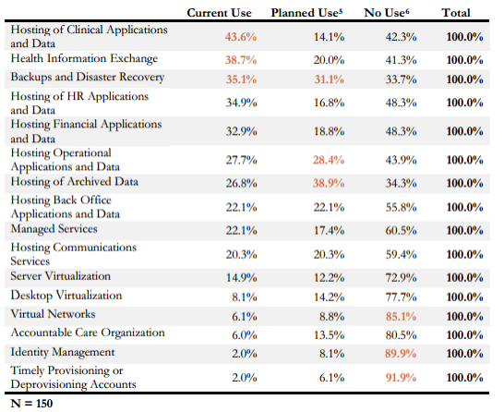

Figure 10. Current areas of cloud applications in healthcare industry

Healthcare organizations mainly use cloud services for administrative functions (73,4%) as for example hosting of financial, operational and HR applications and data and hosting of back office applications and data. The same percentage of healthcare organizations (73,4%) use cloud services also for IT functions as for example hosting of archived data, backups and disaster recovery, hosting of communications services, identity management, timely provisioning and deprovisioning of user accounts, desktop and server virtualization, virtual networks and managed services.

According to CloudCatalyst survey results, respondents from healthcare industry declare the following motivators with very important and important influencing Cloud adoption in this industry (37):

Greater scalability and faster access to infrastructure - 73% of respondents declare greater scalability and faster access to infrastructure as very important motivating factors for Cloud adoption and 18% of respondents declare these factors as important motivating factors for Cloud adoption.

Higher availability – 90% of respondents declare higher availability as very important motivating factor for Cloud adoption and 10% of respondents declare this factor as important motivating factor for Cloud adoption.

Faster time to market and geographical reach - 82% of respondents declare faster time to market and geographical reach as very important factors for Cloud adoption and 9% of respondents declare these factors as important for Cloud adoption.

Cost savings - 55% of respondents declare cost savings factor as very important motivating factor for Cloud adoption and 36% of respondents declare this factor as important motivating factor for Cloud adoption.

Limited in-house technical resources - 45% of respondents declare this factor as very important motivating factor for Cloud adoption and 27% of respondents declare this factor as important motivating factor for Cloud adoption.

Industry specific reasons - 36% of respondents declare that industry specific reasons play very important motivating role in Cloud adoption and 18% of respondents declare that industry specific reasons play important motivating role in Cloud adoption.

Banking

New survey findings from SAP SE and analyst firm Ovum conducted amount IT decisions makers in 400 banks and insurance companies from North America, Europe, Asia Pacific, the Middle East and Latin America has shown a huge demand for cloud technology among retail banks and insurance companies. SaaS solutions are now being considered in almost all new IT investment projects. The same results are seen also on CloudCatalyst survey. The majority of respondents from banking industry (81%) declared the adoption of SaaS, 56% of respondents declared the adoption of IaaS and 25% of respondents declared the adoption of PaaS. Addopted Cloud services support: eMail (87%), Content management (40%), Sales management (67%), Accounting/back office (33%), HRM (31%), IT Development (50%), Security (31%), System & Network management (40%), Online storage, including back-up/disaster recovery (68%), Infrastructure/compute power (46%). According to the same survey, the majority (63%) of adopted Cloud services in banking industry is deployed in private Cloud.

Banks and insurance companies face increasing pressure from new competitors, tighter regulatory requirements and highly demanded customers. Banking organizations are interested in improving and providing highly value added customer services, and better understanding the client relationship. One of the major trends are also big data and challenges about how to manage them. Another focus is related to regulatory requirements and reducing of operational expenses. Security and data privacy remains top concerns for financial organizations. Special challenge is to manage growing use of mobile devices, providing mobile applications and services for customers (view accountants, conduct transactions, etc…). Another important trend is use of social media to listen to customers to improve customer focus and manage risk more effectively.

Based on survey results, 42 % of IT managers expect that SaaS spend will “increase significantly” over the next 18 months, compared to 33 percent among insurers, mostly for operational purposes. SaaS is the preferred option for 27 % of banks and insurers. 42 percent consider cloud services for every IT project. 80% of IT decision makers agreed that SaaS enables organizations to respond more rapidly to market opportunities. Another 79 % agree that SaaS makes it easier for new entrants to the market.

Concerns over regulatory compliance (36%), concerns over reliability and availability (35%) and the difficulty of integration SaaS with existing systems (31%) are considered as the most important barriers to the greater adoption of SaaS among insurance and banking organizations. Despite the benefits, which might be gain by cloud services, the financial industry has been slow to adopt these solutions. Only 14% of financial organizations utilizing cloud solutions have adopted also cloud collaboration services. Security remains top concern while evaluating cloud solutions, what is indicated by 40% of financial companies. Security is also far more important to financial services vendor selection than it is for other industries - 85% of financial organizations indicate security is a top selection criterion, versus only 52% of all survey respondents. Strong focus on security results in strong adoption of private cloud among the financial organizations. However, Gartner predicts that by 2016, more than 60 percent of banks around the world will process the majority of their transactions in the cloud.

According to CloudCatalyst survey results, respondents from banking industry declare the following motivators with very important and important influencing Cloud adoption in banking industry:

Greater scalability - 86% of respondents declare greater scalability as very important motivating factor for Cloud adoption and 14% of respondents declare this factor important motivating factor for Cloud adoption.

Faster access to infrastructure – 93% of respondents declare this factor as very important motivating factor, influencing Cloud adoption.

Faster time to market - 71% of respondents declare faster time to market as very important factor for Cloud adoption and 21% of respondents declare this motivation factor as important for Cloud adoption.

Geographical reach - 50% of respondents declare this motivating factor as very important for Cloud adoption and 36% of respondents declare this factor as important for Cloud adoption.

Cost savings - 64% of respondents declare cost savings factor as very important motivating factor for Cloud adoption and 14% of respondents declare this factor as important motivating factor for Cloud adoption.

Limited in-house technical resources - 29% of respondents declare this factor as very important motivating factor for Cloud adoption and 21% of respondents declare this factor as important motivating factor for Cloud adoption. Others declare this factor as not important / not at all important / not applicable for Cloud adoption.

Industry specific reasons - 36% of respondents declare that industry specific reasons play very important motivating role in Cloud adoption and 36% of respondents declare that industry specific reasons play important motivating role in Cloud adoption.

Retail

Retailers are currently the least likely of all vertical industries to use cloud-based collaboration solutions (2). Nevertheless, "Western European retailers reached a higher maturity level of cloud service deployments compared with few years ago. Although retail companies are more aware of the benefits of cloud computing, the adoption of cloud services in retail industry is still low and, at the moment, mostly limited to some specific modules of enterprise wide services. Furthermore, it is expected that 66.2% of retailers will limit their use of cloud to private clouds, a very small amount of cloud, or no cloud computing whatsoever over the next five years (2). According to IDC, the Western European retail market is still expected to continue to move steadily toward cloud to satisfy different end-user requirements. The pace of the transition is expected to depend on the ability of service providers to continue the cloud education process and to further increase and make more appealing the cloud computing service product range (4). According to this survey, only 5% of retailers indicated they are using cloud-based collaboration, while only 11% of retail cloud users plan to implement cloud collaboration over the next two years.

On the other hand, CloudCatalyst survey results show that the majority of respondents (74%) from retail industry have adopted SaaS. 57% of respondents declared the adoption of IaaS and 39% of respondents declared the adoption of PaaS. Adopted Cloud services support: eMail (77%), Content management (41%), Sales management (55%), Accounting/back office (27%), HRM (26%), IT Development (38%), Security (23%), System & Network management (24%), Online storage, including back-up/disaster recovery (55%), Infrastructure/compute power (45%). Costs predictability seem to be a major driver for cloud computing adoption, even more then cost savings, which are perceived as one of key benefits expected to be gained by cloud computing adoption. According to market research, companies that have successfully adopted cloud services can present the following benefits of cloud adoption:

Better collaboration (ubiquity and mobility)

Leverage mobile technology (virtualized and online Cloud offerings can be tailored for distribution to mobile devices...)

Optimization of costs • Fast time to market (quick service configuration and delivery)

Integration (especially for PaaS and IaaS). Security and data privacy are the two most often referenced barriers to adopting cloud computing.

Referenced studies on cloud adoption – industry specific benchmark

This chapter exposes successful practices of Cloud service adoption in investigated industries, leveraging the benefits of cloud. Besides the description of service implementation use cases, end users share also the opinion on Cloud service motivation factors, potential barriers and challenges. Presentation of successful implementation practices in different industries provides valuable guidelines for other potential users, streaming to business and process optimization. Successful practices of Cloud service adoption - Industry: Healthcare
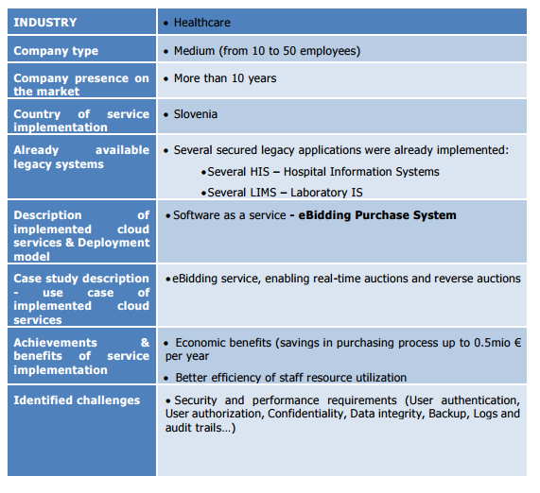

Figure 11. Cloud service implementation in Healthcare industry

Successful practices of Cloud service adoption - Industry: Banking

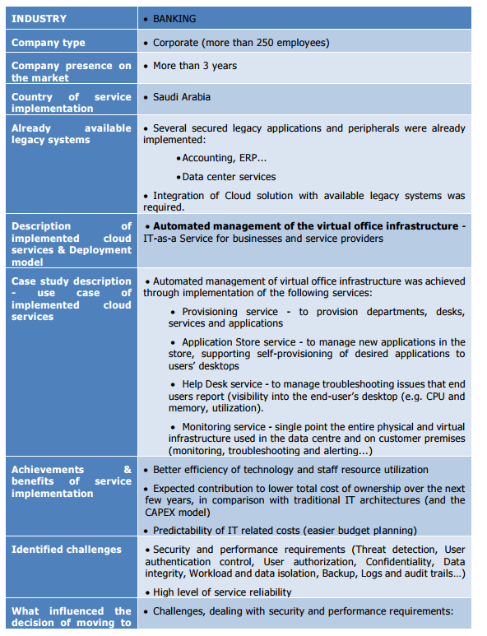

Figure 12. Cloud service implementation in Banking

Conclusion

According to Gartner, in the future years many industries are expected to face intense challenges and at the same time will meet the need to change business models. The need to digitalize the business and be customer-centric is important, and requires new approaches to information delivery, communication and transactions. Business leaders and CIOs should assess their industry-specific strategic requirements, including the demands of business partners, to map out transformation plans based on new technology availability, consumer demographic/behavioral changes and market conditions.

Gartner´s industry predictions for our investigated industries are:

By 2016, poor return on equity will drive more than 60 percent of banks worldwide to process the majority of their transactions in the cloud.

By year-end 2017, at least seven of the world's top 10 multichannel retailers will use 3D printing technologies to generate custom stock orders.

By 2017, more than 60 percent of government organizations with a CIO and a chief digital officer will eliminate one of these roles.

Furthermore, by year 2020, 80 percent of health data is expected to pass through the Cloud at some point in its lifetime, as healthcare providers continue to leverage hosted infrastructure for data collection, aggregation and analysis3 . Seven of ten healthcare organizations worldwide are planning to invest in consumer-facing apps, technologies, wearable's and virtual care by 2018 to help reduce costs.

Next, in media and entertainment industry, Cloud is expected to play an important role in the delivery of content-rich services to multiple devices. Also, Cloud services are expected to be increasingly used to analyze customer habits and preferences. Also, researchers estimated the global cloud computing in education market will be worth $12.38 billion by 2019, up from $5.05 billion this year.

