WP 1 – Review and analyze best EU and global practices in cloud computing

DEV 1.3 – Analyses of current practice in ICT developemnt in ME

Authors:
Prof.dr Ramo Šendelj, UDG
Assist. Prof.dr Ivana Ognjanović, UDG

Table of Contents
1. Introduction 3
2. ICT development in Montenegro 3
2.1. ICT literacy in Montenegro 3
3. Analyses of ICT solutions in Montenegro 17
4. Conclusion 17

Introduction

ICT development in Montenegro

2.1. ICT literacy in Montenegro
The Statistical Office of Montenegro conducted a survey on ICT usage in the period from 1 to 15 April 2014. The survey refers to the ICT usage in households, by individuals, and in enterprises. The ICT usage survey which was conducted in households, according to the Eurostat methodology, includes households with at least one member aged between 16 and 74 years old, and individuals of the same age. 1 200 households, with 1200 individuals, were interviewed face-to-face. The ICT usage survey which is conducted in enterprises covers 578 enterprises with 10 or more employees from 10 business sectors according to NACE Rev. 2; who were interviewed by telephone. Table 1 identifies the organizations and entities referred to cyber security. A cursory look at this table indicates that the cyber security system is a complex assortment of national, international, and private organizations. Parallel to the organic fashion in which cyberspace itself developed, these organizations often have unclear mandates or possess overlapping spheres of influence. At this stage we seek only to highlight the major entities and, to the extent possible, to signal their relationships and interconnections.
Summarized data shows that:
- Percentage of households that have access to computers is 53.7%.
- Percentage of households with Internet access at home is 63.6%.
- Percentage of households with TV set access (in house) is 99.2%.
- Percentage of households with mobile phone is 93.6%.
Figure 1 gives trend of using devices in last three years in Montenegro.
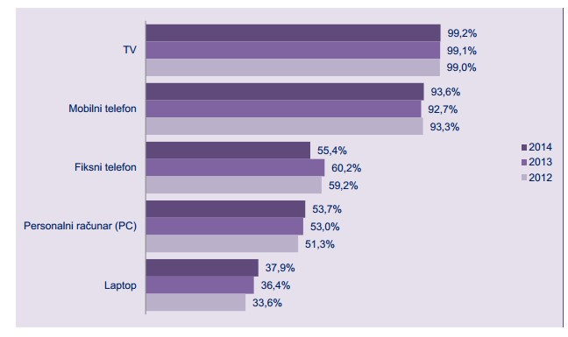
Figure 1: Use of devices by households
Furthermore, access to cyber space is characterized with the following data:
- Access to the Internet via a PC achieves 75.1% of households that have Internet access.
- Access to the Internet via a laptop achieves 57.6% of households that have Internet access.
- Access to the Internet via a mobile phone achieves 38.5% of households that have Internet access.
Figure 2 presents participation of technology in the total number of broadband connections. It shows that:

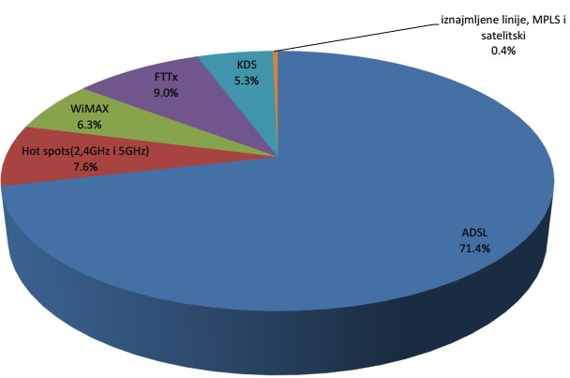
Figure 2: Participation of technology in the total number of broadband connections in Montenegro
- Of the households that have access to the Internet, 79% answered that they use DSL or some other type of fixed broadband connection to the Internet.
- Of the households that have access to the Internet, 29.6% answered that they use 3G or some other type of mobile broadband connection to the Internet.
It is interesting to consider what reason for having no access to the Internet, since
33.2% said that they have a lack of ICT literacy in using it (see Table 1).
Table 1: Reasons for having to access to the Internet
Reasons | Percentage (%)
I do not want to have Internet access | 36,8
I have lack of ICT literacy | 33,2
Internet access is too expensive | 29,9
Equipment is too expensive | 27,8
Physical disability | 9,5
I have Internet access at some another place | 7,5
Broadband connections are disabled | 5,8
Other reasons | 19,6

Furthermore, use of Internet by individuals is represented with (see Figure 3):
- The percentage of persons who used a computer in the last 3 months is 64.5%. • The percentage of persons who never used a computer is 30.6%.
- As for the use of the Internet, 63.9% of them reported that they had used the Internet in the last 3 months.

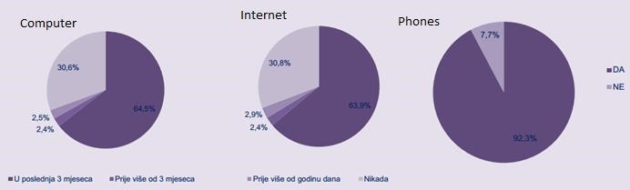
Figure 3: Use of computer, Internet and smart phones in last 3 months
Also, we have deeper analyses of Internet users (based on age category), presented in Table 2.
Table 2: Use of Internet based on age category and gender (ratio is calculated to the total number of Internet users in last 3 months)
Use of Internet |  |  | Age category |  |  |  | Gender
 | 16-24 | 25-  34 | 35-  44 | 45-  54 | 55-  64 | 65-74 | Male | Female
Every day or almost every day | 89,9 | 85,7 | 83,0 | 72,3 | 68,7 | 39,0 | 8,5 | 80,7
At least once a week | 8,1 | 13,2 | 15,7 | 18,3 | 19,8 | 56,0 | 14,5 | 15,1
Less than once a week | 2,1 | 1,1 | 1,3 | 9,5 | 11,5 | 5,0 | 3,1 | 4,1

Furthermore, kinds of activities that users of Internet in last 3 months have used are presented on Figure 4, while Figure 5 gives more information regarding for which kind of activities users are aware and capable to use.

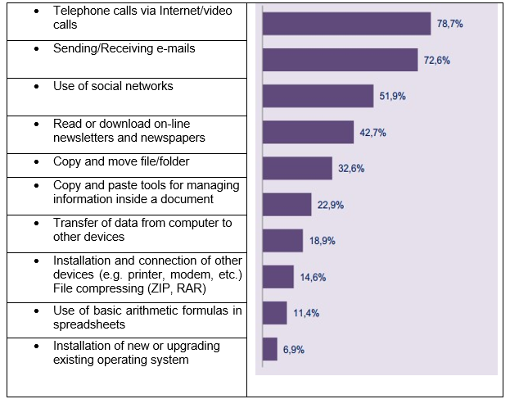
Figure 4: Kinds of activities that users performed via Internet in last 3 months (this question is with multiple choices)
The following indicators show the use of e-government services by individuals and provide information on the perceived quality of public authorities' websites and satisfaction with e-government services. They cover contacts or interactions with websites concerning citizen's obligations, rights, official documents, public educational services and public health services.
Methodology that was used for estimation is developed by EU and company Campaign (source: www.euprava.me). Level 1: on-line information; level 2: one directional interaction (information and forms download), level 3: both directional (on-line submission of forms, authentication), level 4: transaction (complete processing of subject, on-line payment services), level 5: personalization: My portal.
Table 3: 20 Basic Services of e-Government
20 Basic Services of e-Government
Name of Service | Max  Level | MNE  Level | Name of Service | Max  Level | MNE  Level
Services for Individuals |  |  | Services for Legal Entity
Submitting taxes | 5 | 4 | Social Insurance for  Employees | 4 | 2
Searching for job | 4 | 3 | Calculation, registration and payment of taxes | 4 | 4
Social Help | 5 | 1 | VAT | 4 | 2
Personal Documents | 5 | 1 | Firm Registration | 4 | 3
Car Registration | 4 | 1 | Sending Data to the  Statistic Department | 5 | 4
Building Permits | 4 | 2 | Customs Declaration | 4 | 4
Police Reporting | 3 | 2 | Ecological Permits | 5 | 2
Public Libraries | 5 | 3 | Public Procurement | 4 | 2
The documents (list of births, deaths, marriages  ...) | 4 | 4
Application and  Enrolment to High  School | 4 | 2
Changing Permanent  Address | 5 | 1
Health Services | 4 | 2

Overall, there seems to be considerable scope for improving e-government services and increasing take-up by individuals in the future.
To summarize presented data, type of activities that are performed by individuals in Montenegro is characterized with the following numbers:
- Number of persons that in the last 3 months bought or ordered goods or services over the Internet is 7%, while the percentage of those who have never bought or ordered goods or services is 81%.
- Percentage of Internet use every day or almost every day is marginally higher in men and is 82.5%, while 80.7% of women.
- 93.9% of surveyed enterprises use computers in their business.
- The survey showed that 98.1% of enterprises that use a computer have Internet access.
- Of the enterprises that have access to the Internet, 73.3% answered that they have a Web Site / Home Page.
- Of the companies that have access to the Internet, 96.5% said they use DSL or some other type of fixed broadband connection to the Internet.
On the other side, use of Internet in business sector is characterized with data presented on the following figures.
Figure 6 shows the use of computers and Internet access in enterprises in Montenegro.

MISSING
Figure 5: Missing
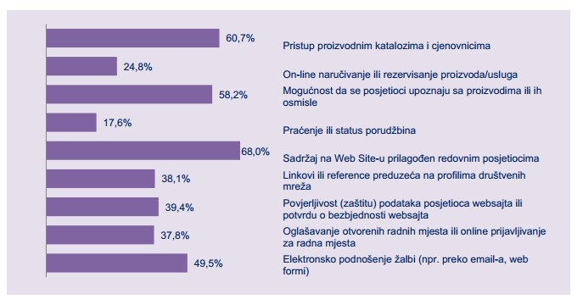
Figure 6: Use of computers and use of Internet in enterprises in Montenegro
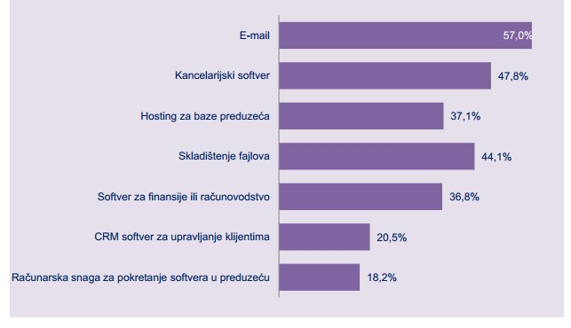
Figure 7: Which kinds of services are provided by using Web Site of the enterprise.
MISSING
Figure 8: the use of cloud computing services at enterprises in Montenegro.
The activity of e-commerce at enterprises in Montenegro are presented on Figure 9.

MISSING
Figure 9: The activity of e-commerce at enterprises in Montenegro
All these data presented above were collected by Montenegrin bodies, and to the best of our knowledge this is the most comprehensive analysis about use of ICTs in Montenegro.
On the other side, data presented in The Global Information Technology Report 2014 give estimation of the Networked Readiness Index with the value of 4.3 (max value 7). The index is estimated with several factors (Environment sub-index, Readiness, Usage sub-index, Impact sub-index), but the most relevant one for ECESM project is Usage sub-index (Figure 2)

MISSING
Figure 10: Numerical data about ICT experts in Montenegro
The quantity, as well as quality, of human resources available to the ICT sector is potentially high.
Recent data from 2013 [] shows that, in the Montenegrin IT market actively participates only 219 companies although according to data CRPS there are 560. The entire IT sector employs 592 employees which makes an average of 2.7 employees per enterprise.
On the other side, educational programs at Montenegrin universities are more promising, providing higher level of education in ICT field, while general ICT literacy in primary and secondary schools are not still enough included, as follows.
- There are five Faculties in Montenegro whose mission is to provide students with the knowledge and skills necessary to the ICT sector; three at the University of Montenegro (ETF, PMF and the Faculty of Economics - Management in Information Technology), one at the Mediterranean University (FIT) and one at the Universityof Donja Gorica (FIST).

- In the last eight years, since the introduction of the so-called "Bologna" in 2006, more than two thousand students received their degrees from the ETF, PMF and FIT. Of these, more than 1400 students have graduated with a degree in applied computer science.
The number of graduates represents a remarkable potential for the development of the ICT sector. There is a mismatch between the number of people with a university degree in the field of ICT and the small number of employees in the ICT sector.(According to the official data, the ICT sector employed 592 people in 2013).
The study of ICT subjects in primary and secondary schools is of great importance for the computer literacy of the nation and prerequisite for the development of the cyber secure society. The current offer of the compulsory and optional subjects in elementary and high schools is as follows. The compulsory subject Informatics is taught in the sixth grade of elementary school. The optional subjects in elementary schools are: Computer Processing, Creating Graphics and Image Processing, Creating Multimedia Slide Shows and Introduction to Programming. In high schools, the compulsory subject ``Informatics’’ is taught two hours per week. The optional subjects are: Computer and Web Presentation, Business Informatics, Algorithms and Programming. The opinion of ICT professionals is that the number of compulsory ICT subjects must be higher.
Even the numbers about general ICT education are much more impressive then realistic, optional subjects in elementary school have not been organized yet, so only one ICT subject is organized in elementary schools. Consequently, programs at university level are on basic ICT literacy level, since students are not educated properly at lower educational level.
It is also interesting to note that, Montenegrin educational system recognizes the role of ICT coordinator in each school. Their role is defined with major activities related to use of ICTs by both, students and other users at schools, such as: (i) System maintaining; (ii) Applying failures; (iii) Software installation; (iv) Installation and monitoring of Antivirus protection; (v) Network monitoring ; (vi) Mobilization and help in ICT using; (vii) Training colleges to use ICT; (viii) Assistance to colleagues in using of electronic didactic materials; (ix) Participation in the school portal; (x) Internet maintain in schools; (xi) Childs’ safety on the Internet; (xii) Environmental protection; (xiii) Online magazine for teachers, (xiv) Useful links and applications. Thus, the position of ICT coordinators shall be considered as a central for providing educational activities among pupils at schools, their teachers as well as parents.

Analyses of ICT solutions in Montenegro

Conclusion

