WP 3–Model of Cloud Computing Services for SMEs in Montenegro

DEV 3.4–Validation of created model: prototyping and evaluation

Table of Contents
1. Introduction 3
2. Section II 4
3. Section III 5
4. Section … 6
5. Conclusion 7

Introduction
This document is created as to summarize results of activity 3.4. Validation of created model: prototyping and evaluation within WP3- Model of Cloud Computing Services for SMEs in Montenegro. The activity was aimed on selecting specific services and moving them to cloud environment.
Having in mind that innovative CCS model which is proposed as a key result within activity 3.3 Creation of CCS model for SMEs in ME clearly identified 3 different domains of applications, namely: academia, local authorities, and businesses; services for prototyping are selected from two different fields: academia and local authorities.
The following sections are introducing the services and describing their functionality.
The document is organized as follows: Section II presents Prototype 1- Citizens voice for municipalities, Section III presents Prototype 2- Office 365 Cloud in schools in Montenegro, while Sections IV and V gives evaluation results of developed services and CCS model in general, respectively.

Protoype 1- Citizens voice for municipalities
The service is an example of cloud based solution usage, aimed to increase transparency in communication between citizens (civil society) – Municipality. The service enables collecting and processing initiatives for actions initiated by citizens, which will be supported by the Municipality, and forwarded into further procedure as its own initiative, in case these initiatives receive the legal envisaged number of citizens votes. The Service aim is to help citizens, to participate more effectively in their countries political life, and to influent the process of creating public affairs.
Citizens voice for municipalities is developed and implemented as the user friendly surrounding for starting initiatives, and submitting an online petition. Portal has two functional segments, which appear as a single unit to a final user, dividing clearly the part of the portal managing the flows of the petitions (summation, support, search etc.), from the part uncharged of administrating and managing the control of accurate usage of users’ personal data, communication with competent municipality institutions, adoption of petitions publication, etc.
The part of the portal being arranged through CMS (Content Management System) is completely flexible, and arranged with needs and requests, achieving full accuracy, confidentiality, transparency and legality of implemented procedures, necessary for operating the public part of the portal. This part of the portal has the possibility to change and customize to emerging needs in the production phase of its life, without further programing.
Public part
The public part of service is customizable website with at least 4 tabs:
- Home page
- Petition
- Voting
- Create new petition
The home page is practically welcome page with information about petition. That information are divided into three groups: the most popular petitions, the latest petitions and petitions with close deadline. The image below shows the look of the home page:
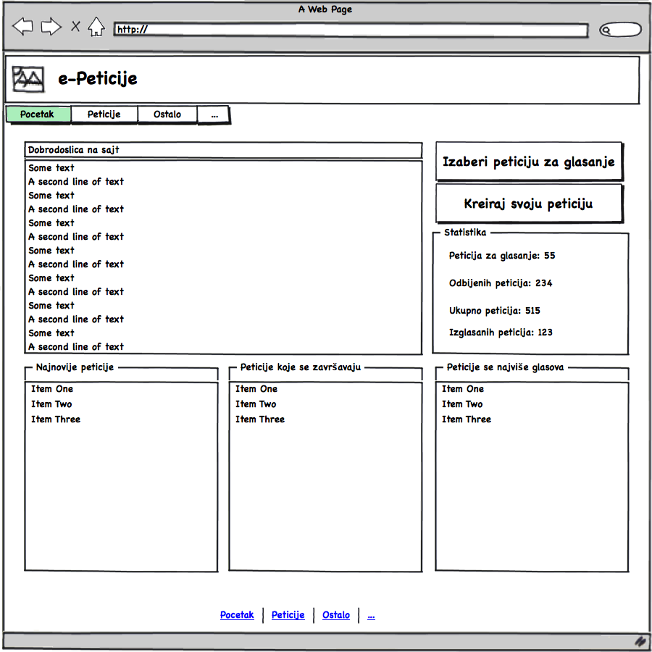
Petition tab lists all active and inactive petitions, in the grid, as shown on the following image:
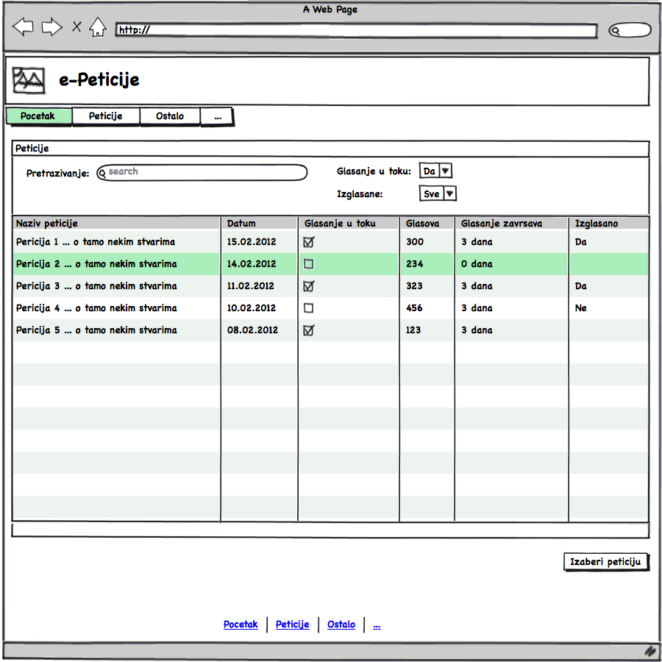
The user can search the petitions by different criteria, by filtering petitions in relation with their active status or voting status. After finding the requested petition, user can select, open and vote. Voting tab is shown on the figure below:
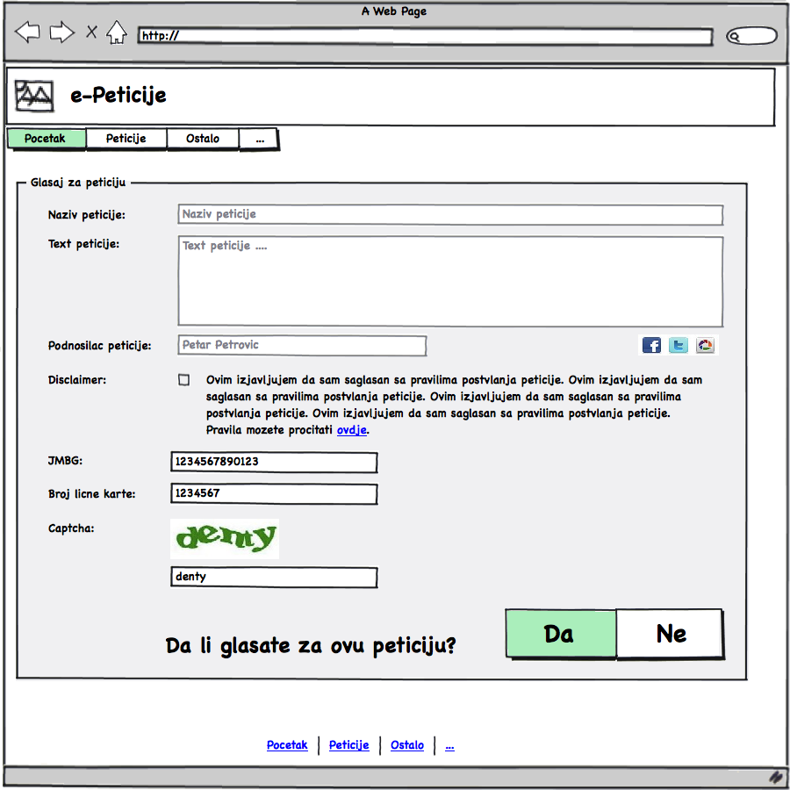
The name and description of the petition that has been selected is clearly displayed on the form. Users are required to confirm the statement of the petition by pressing the check box. After this confirmation, users need to enter their Unique Master Citizen Number and number of Identity card, as well as to fill the special validity "captcha" field. Then user is clearly asked does he want to give his signature (the voice) to the petition. The user can press yes or no button. Immediately after the users confirm the action, the system proceeds the data to the citizens' base in the Ministry of Interior Affairs, via a special secure connection (SSL web site) and requests confirmation of the user. If the citizen's service returns a negative response, the user is warned about this and the program offers him an option to re-enter Unique Master Citizen Number and number of Identity card.
After successfully submitted petition, the users get information about it and the display shows the text to thank users for participating, as shown on the next figure.
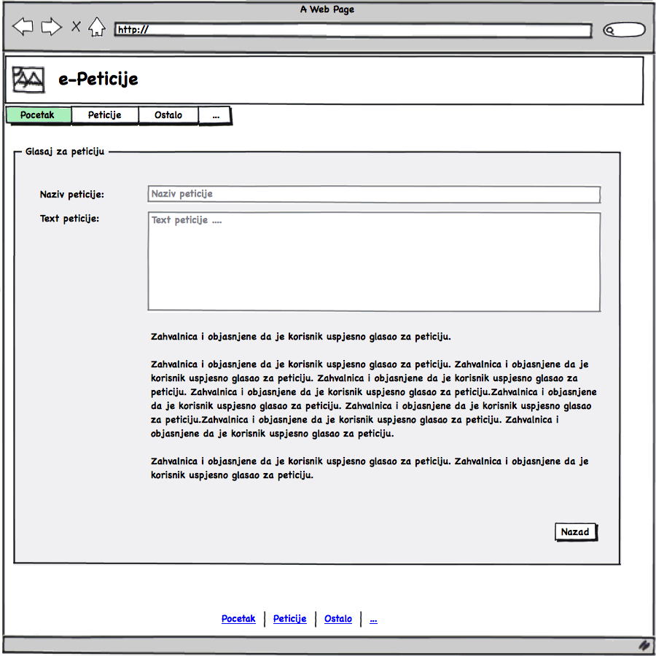
Each visitor to the portal can create new petition. This is strict and formal procedure, consisted from three steps.
Firstly, the user has to enter:
- Title of Petition (max 150 characters)
- Description (max 1000 characters)
- Number of days for voting (7, 15, 30, 45 or 60 days).
The figure below shows this step.
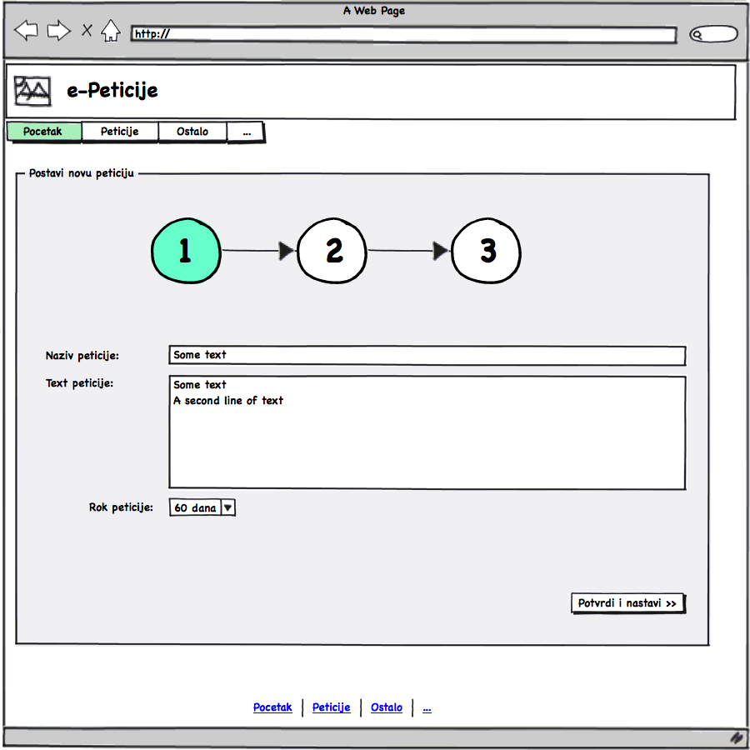
In the second step, service requires from user to enter his personal information: name, surname, Unique Master Citizen Number, Identity card number, email address, to confirm privacy regulation and enter some symbols in “captcha” field.
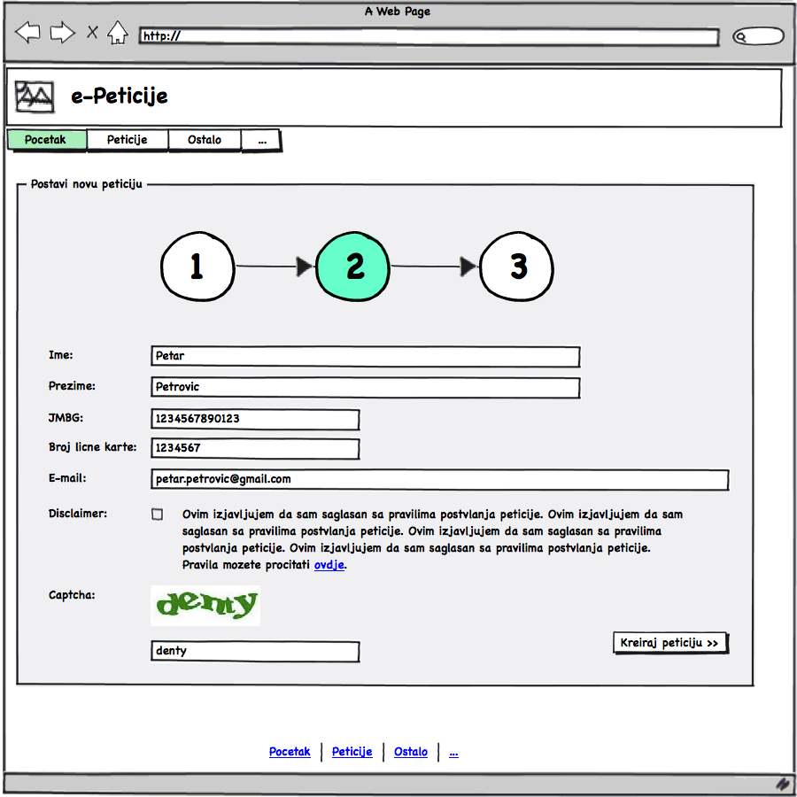
After submitting petition, the system automatically checking the entered data with citizens database of Ministry Interior Affairs, and if the entered data are correct, the petition will be posted on website, and the user will be informed via email about it.

Prototype 2- Office 365 Cloud in schools in Montenegro

After making analyses of existing processes of teaching and education, and identification of key challenges in providing support to ICT enabled communication and cooperation, storages for educators and learners, ICT support to presentations and school social networks, proposed prototype is created by using Microsoft Office 365 solution and making it adopted to selected schools in Montenegro.
Office 365 Cloud in schools in Montenegro - is implemented in close cooperation between ITAS, Čikom Ltd, Ministry of education Montenegro and Microsoft Montenegro. After making analyses of existing processes of teaching and education, and identification of key challenges in providing support to ICT enabled communication and cooperation, storages for educators and learners, ICT support to presentations and school social networks, proposed prototype is created by using Microsoft Office 365 solution (since ITAS and Čikom are their gold partners) and making it adopted to selected schools in Montenegro.
This prototype is adopted in the 5 elementary schools: JUOŠ „Maksim Gorki“Podgorica, JUOŠ „VeljkoDrobnjaković“ Risan, JUOŠ „VladimNazor“ Podgorica, JUOŠ „RadojicaPerović“ Podgorica, JUOŠ „Oktoih“ Podgorica, and one secondary school – High School “MirkoVešović“ Podgorica.
It is anticipated to organize trainings for director, administrative and teaching staff from the selected schools.
The training is organized in 6 modules.
The first module is focused on introduction of Office 365 cloud to users. This module contents generally explanation what is cloud and the benefits of using cloud services in comparison with on-premise ICT solutions. After completing this module, the trainees will be aware about initial investment in cloud services, maintain and administrative expenditures, as well as simplicity of cloud service usage.
The second module is oriented on components and characteristics of Microsoft Office 365, and has theoretical and practical part. After completing this module, the trainees gain knowledge how to log on Office 365 Account, how to work with Office 365 online components in educational package, and offline components (MS Office apps, Skype for business, One Drive). Also, this module capacitates trainees to create/change user accounts and passwords, and introduce them with privacy settings of Office 365.
Email service is in the focus of third module. The trainees learn how to use Web mail, Microsoft Outlook, global address lists for email sending, and how to use and edit contacts and calendar/events.
Education and preparing trainees to use benefits of One Drive is anticipated for fourth module. They get knowledge about configuration and using One Drive account, online work on documents, saving documents/changes, sharing and back up of files.
The fifth module is reserved for using ICT services to have distance meeting/presentations. This module contents presentation about using: Skype for Business (installation of application, singing in, logging), Chat, Audio & Video Call, Audio & Video Conferences, as well as sharing their presentations and desktop with someone who is on the distance.
The last module is presentation of school social network Yammer. This is the most important module for interaction with students. The module content useful presentation about Yammer components, creating and managing with groups, accessibility and post sharing.

Evaluation

Functionality
Functionality testing is performed by conducting evaluation procedure over the following scenarios:
Scenario 1.Creation of new e-petition
Steps:
- User has to choose from menu option „Petition“.
- System opens the page with all petitions in grid.
- Table shows all petitions, if the search by filter is not active.
- The user can search the petitions by different criteria, by filtering petitions in relation with their active status or voting status.
- At display Petition List there is option for searching by word.
Browser will search all petition by requested criteria.
Searching is possible for all fields of petition – title and description.
- The user has to enter Title of Petition (max 150 characters)
- The user has to enter Description (max 1000 characters)
- The user has to enter Number of days for voting (7, 15, 30, 45 or 60 days).
- After submitting the requested information in the first step, user should click button “Confirm and continue“.
- In the second step, service requires from user to enter his personal information.
- User has to enter his (required using of Montenegrin letters - ŠĆŽĐČ)
- Name
- Surname
- Unique Master Citizen Number
- Identity card number
- E-mail address
- Confirm Terms of using service
- After this step, user should click on button „Create petition“.
- System informs user about successful creation of petition.

Scenario 2. Petition voting
Prerequisites. (1) User accessed to the system; (2)User is located at the page with listed available petitions.
Steps:
- User has to choose from menu option „Petition“.
- System opens the page with all petitions in grid.
- Table shows all petitions, if the search by filter is not active.
- The user can search the petitions by different criteria, by filtering petitions in relation with their active status or voting status.
- At display Petition List there is option for searching by word.
Browser will search all petition by requested criteria.
Searching is possible for all fields of petition – title and description.
- Searching by voting status, user can choose filter to show only petiton that are in voting process, or petitions for which the voting proces is finished, or to show all petitions
- After finding required petitions, user has to select it and open to vote.
- The voting form shows title and description of choosen petition.
- Service requires from user to enter his personal information (required using of Montenegrin letters - ŠĆŽĐČ).
- User has to enter his
• Name
• Surname
• Unique Master Citizen Number
• Identity card number
• Confirmation
• Code for verification (CAPTCHA)
- System informs user about successful voting.

Scenario 3. Petition validation
Prerequisites. (1) Responsible person is logged on the system as administrator
Steps.
- User can see only petitions for which he is authorized.
- User can sort the list by following columns on grid:
- Title of petition
- Validation status
- Voting in process
- Closed for voting
- Reclamation
- Semaphore (validation period)
- Number of votes
- Date of petition submission
- Date of voting start
- User can also to filter listed petition by required criteria:
- Processing period
- Validation status
- Voting status
- Number of votes
- Semaphore
- After finding required petition, user opens petition by click on
- Validation form is opening.
- On validation form, user chooses one of three options:
- Accept petition
- Reject petition
- Send petition on editing
- If petition completes all defined criteria, user chooses action “Accept petition”.
- If petition do not completes all defined criteria, user chooses action “Reject petition”.

Scenario 4. Petition supervisions
Steps.
- Supervisor sorts the list by following columns on grid:
- Title of petition
- Validation status
- Voting in process
- Closed for voting
- Reclamation
- Semaphore (validation period)
- Number of votes
- Date of petition submission
- Date of voting start

- Supervisor can filter all petition by the following criteria:
- Search by any word in petition
- Processing period (deadline)
- Validation status
- Voting status
- Number of votes
- Semaphore
- After finding required petition, supervisor opens petition by click on icon .

Conclusion: All functionality tests are successfully passed!

Security
From the security issues, it is ensured that all data are encrypted and stored in database. On the other side, users’ issues about security challenges on clouds are still opened.

Conclusion: On the bases of performed scenarios, there is no evidence about any violation of data security.

Easiness of use
During testing phase, all users are invited to report any problems that occurred related to easiness of use and following the instructions.

Conclusion:There is no evidence about reported issues related to lack of easiness of use and following the instructions.

Evaluation of overall CCS model

number of potential end users, possibilities for replication, privacy and cyber protection, maintenance costs, infrastructure investments, etc.

