WP 3 – Model of Cloud Computing Services for SMEs in Montenegro

DEV 3.1 – Assessment of drivers for Cloud Computing Adoptions by ME SMEs

Table of Contents
1. Introduction 4
2. Types of Cloud Services 5
2.1. Public Cloud 6
3. Cloud Service Models 9
3.1. Platform as a Service (PaaS) 10
3.2. Infrastructure as a Service (IaaS) 10
3.3. Software as a Service (SaaS) 11
4. Factors affecting selection of appropriate cloud model as Per the Business Benefits 12
4.1. Flexibility 12
4.2. Scalability 13
4.3. Security 13

1. Introduction
This report is focused on making sensitive research on possibilities for using different deployment cloud models and different cloud services in different fields in Montenegro. The research is aimed on: (i) making comprehensive view on different services and applications moving to the cloud and (ii) analyzing which cloud service model (IaaS, PaaS, or SaaS) that best addresses business requirements.

2. Types of Cloud Services

Cloud services are mainly categorized on the basis of access, size and proprietorship. In the following sections, the main cloud deployment models are described.

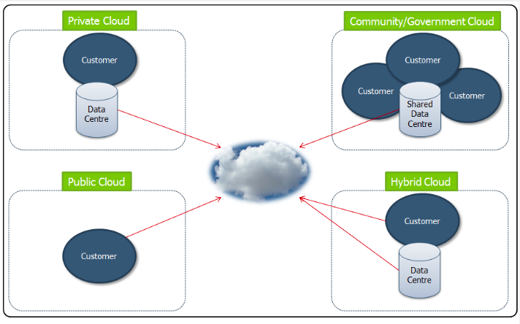
Figure 1. Cloud basics – Deployment models

2.1. Public Cloud
The service provider opens up the cloud infrastructure to open use. The infrastructure will be in the premises of the service provider, but it will be operated by whoever is making use of it, be it government organization, business centers or academic institutions. The user, however, does not have any control over the location of the infrastructure.
The main features of the public cloud are:
- Reasonable levels of security
- Easy to implement
- Cost-effective
- Low operational cost
However, you need not go for this option if security is of utmost importance.

2.2. Private Cloud
Private cloud, as the name suggests, is solely owned by a particular institution, organization or enterprise.
Hosted internally or externally, private cloud services offer better security, especially for companies that need excellent data management services and uptime requirements. It is also the best choice for organizations that need to manage their host applications and other applications used by their customers.
The main features of the private cloud are:
- Maximum levels of reliability and scalability
- Designed for enterprises and businesses
- Greater control over cloud infrastructure
- Users get both network access and computational resources
Interestingly, there isn’t much of a difference in the design structure between public cloud and private, save perhaps, for the level of security.

2.3. Hybrid Cloud
As the name suggests, hybrid contains the best of private, public and community (another type of cloud service). Hybrid solutions ensure safety, scalability and performance, but you really need a reputed hybrid cloud vendor to ensure reliability, especially because diverse environments are involved.
But it can definitely leverage the cost benefits to a great extent and even manage the vulnerabilities found in mission critical data applications.
And many businesses have already adopted hybrid solution because it allows for the BYOD or Bring Your Own Device policy, while employees can access business critical applications and information to improve collaboration. A hybrid system definitely promotes a more personalized approach.

The picture below gives an overview of deployment models.
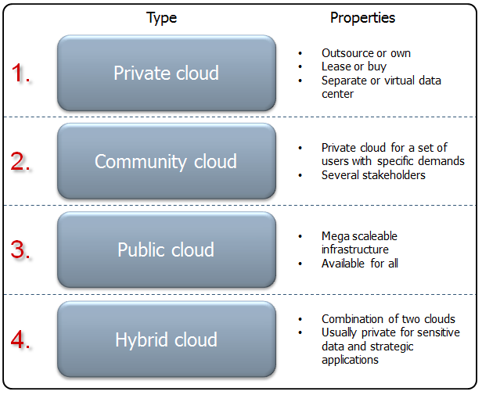
Figure 2. Overview of deployment models

3. Cloud Service Models
There are actually more service models than the three (IaaS, PaaS, SaaS) widely in use today. Service models like Data Analytics as a Service and HPC/Grid as a Service are emerging as useful models. How one Selects the appropriate service model depends on factors such as availability of suitable application software Need for development and test environment, need for effective computing infrastructure control and management required distribution of data, services, and infrastructure, existence and complexity of enterprise IT infrastructure and datacenter/warehouse.

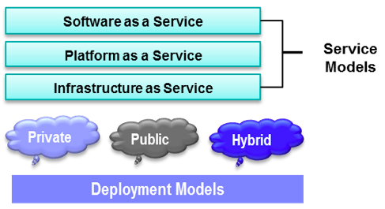

3.1. Platform as a Service (PaaS)
A fairly new technology in the cloud computing scenario when compared to IaaS, Platform as a Service (PaaS) runs atop IaaS. It is mainly targeted towards the developer as it allows them to build applications and services over the internet.
PaaS is hosted over the cloud, and their users can access it through a web browser. The highlight of PaaS is that it can support the entire web app development cycle, right from building and testing to final deploying, managing and updating. Businesses can requisition resources for scaling as their demand grows, so they don’t have to invest in hardware anymore.

3.2. Infrastructure as a Service (IaaS)
Infrastructure as a Service or Cloud Infrastructure is a self-service codes that aims to manage and monitor remote datacenter infrastructure for the following functions: compute, storage and networking.
The cloud service provider delivers the infrastructure while the clients get to decide on the operating system of their choice. They scale and spin virtual machines of their choice.
The entire responsibility of scalability, initial provisioning of system and connectivity falls on the hands of the vendor. You need a team of system administrators to monitor and manage the system, its maintenance and firewall aspects.
Companies using IaaS services have to manage their applications, data loss, runtime, middleware. Apart from the virtualization layer, cloud vendors in IaaS also provide messaging queues and databases as well. Amazon Web Services (AWS), Microsoft Azure are all perfect examples of IaaS.

3.3. Software as a Service (SaaS)
Software as a Service (SaaS) is perhaps the most commonly used cloud deployment model. This is because the web delivery model eliminates the need to install and run applications on your computer, apart from making it easier for businesses to streamline their maintenance and support.
The vendors themselves manage the service, including applications, data, middleware, runtime, server, storage, virtualization, networking and even the Operating systems. Google Apps, Citrix GoToMeeting and Cisco WebEx are all perfect examples of SaaS.

4. Factors affecting selection of appropriate cloud model as Per the Business Benefits

In this Section we give overview of various cloud models from the aspect of the key factors that determine the cloud model.

4.1. Flexibility
Here, we are talking about flexibility in terms of cost. Cloud implementations give you the opportunity to use the resources and pay for them as you go along. If you choose to go for the ‘variable costing’ method, it would be helpful in future upgrades.

4.2. Scalability
As changes in business often cause budget challenges, it is so important to upgrade your cloud model. Such a vendor would understand and predict the future requirements of its clients, and provide critical services. IaaS provides you with the highest level of scalability.

4.3. Security
Security of data is a critical factor to consider. It is important to understand the backup plans of the cloud vendor in the event of an outage or crash. After all, your data shouldn’t reach wrong hands. It advisable to keep highly sensitive data behind a firewall, and outside of the public cloud realm.

Since orientation of governmental and public services to be deployed on clouds is one of important aspects for Montenegro (as it will be presented in Deliverable 3.3), it is important to provide comprehensive overview on different deployment models, as follows::
Private Cloud: The cloud infrastructure is used exclusively for internal applications within an organisation comprising multiple consumers (e.g., business units). It may be owned, managed, and operated by the organization, a third party, or some combination of them, and it may exist on or off premises.
Community Cloud: The cloud infrastructure is used exclusively by multiple organizations that have shared concerns (e.g., mission, security requirements, policy and compliance considerations). It may be owned, managed, and operated by one or more of the organizations in the community, a third party, or some combination of them, and it may exist on or off premises.
Public Cloud: The cloud infrastructure is provisioned for open use by the general public. It may be owned, managed, and operated by a business, academic, or government organization, or some combination of them. It exists on the premises of the cloud provider.
Hybrid Cloud: The cloud infrastructure is a composition of two or more distinct cloud deployment models (private, community, or public) that remain unique entities, but are bound together by standardized or proprietary technology that enables data and application portability (e.g. cloud bursting for load balancing between clouds).

The following table summarizes the pros and cons of the different deployment models.

Option | Pros | Cons
Private Cloud | + More control and reliability: IT can control the security of data, set compliance requirements, and optimize networks more effectively with cloud.  + Customizable: IT can customize storage and networking components so that the cloud is a perfect fit for the specific organization and its needs. | – Requires IT expertise: A high-level of IT expertise is required to ensure maximum effectiveness and optimal configuration of the deployment.  – Costlier: The long-term costs may be higher due to increased management responsibilities and smaller economies of scale.
Public Cloud | + Ease of management: Organisations IT departments do not manage their public cloud; they rely on Cloud provider to administer the cloud.  + Ease of deployment: With the public cloud, there is low barrier to entry, so you can quickly configure and stand up a cloud.  + Flexible: Users can add or drop capacity easily. Moreover, the environment is typically accessible from any Internet-connected device, so users don’t need to jump through many hurdles to access. | – Can be unreliable: Public cloud outages are quite common, leading to headaches for users.  – Less secure: The public cloud often has a lower level of security and may be more susceptible to hacks. In some cases, cloud providers may not be able to meet the strict constraints mandated by government institutions.
Hybrid Cloud | + Flexible and scalable: Organisations are able to combine and match for the ideal balance of cost and security.  + Cost effective: Organisations can take advantage of the cost-effectiveness of public cloud computing, while also enjoying the security of a private cloud. | – Complexity of management: Moving parts between public and private clouds can be a challenge.  – Requires IT expertise: A high-level technical staff is required to guarantee security vulnerability on all aspects is decreased.

https://www.visma.com/blog/cloud-basics-deployment-models/
https://www.visma.com/blog/cloud-basics-deployment-models/
http://www.storm-clouds.eu/services/resources/best-practices/choose-the-right-cloud-deployment-model/

