Capacity building & Dissemination event- Report

Organising institution: IT Advanced services ltd

Venue: Training of ITAS employees
Place: IT Advanced services ltd, Dalmatinska 78, Podgorica, Montenegro
Date: 08/06/2017

Agenda:
10:00-10:45 Next-generation cloud technologies: cloud and container technologies and tooling support
10:45-11:30 Scalable and performing computers, storage and network solutions
11:30-12:00 Coffee break
12:00-12:45 Characteristics of the different cloud technologies
12:45-13:30 Examples of Solutions employed by companies to meet their business demands
13:30-14:00 Q&A

Narrative report
The training for ITAS employees – software developers and programmers, was organized on 8th June 2017, at premises of ITAS. The trainer was Prof. dr Dragan Đurić, from IMTM.
The training was focused on activity about technical issues of developing and maintaining cloud based solutions for company ITAS. The first part was oriented on new techniques in cloud computing and work with them. The second topic of training was reserved for scalable and performing computers, storage and network solutions. The different techniques in cloud computing development and its cross matching was in focus of third part, while the last issue was practical examples and good practice examples.
The training was attended by 8 participants – 7 trainees from ITAS ltd and 1 trainer from IMTM.

Photos:
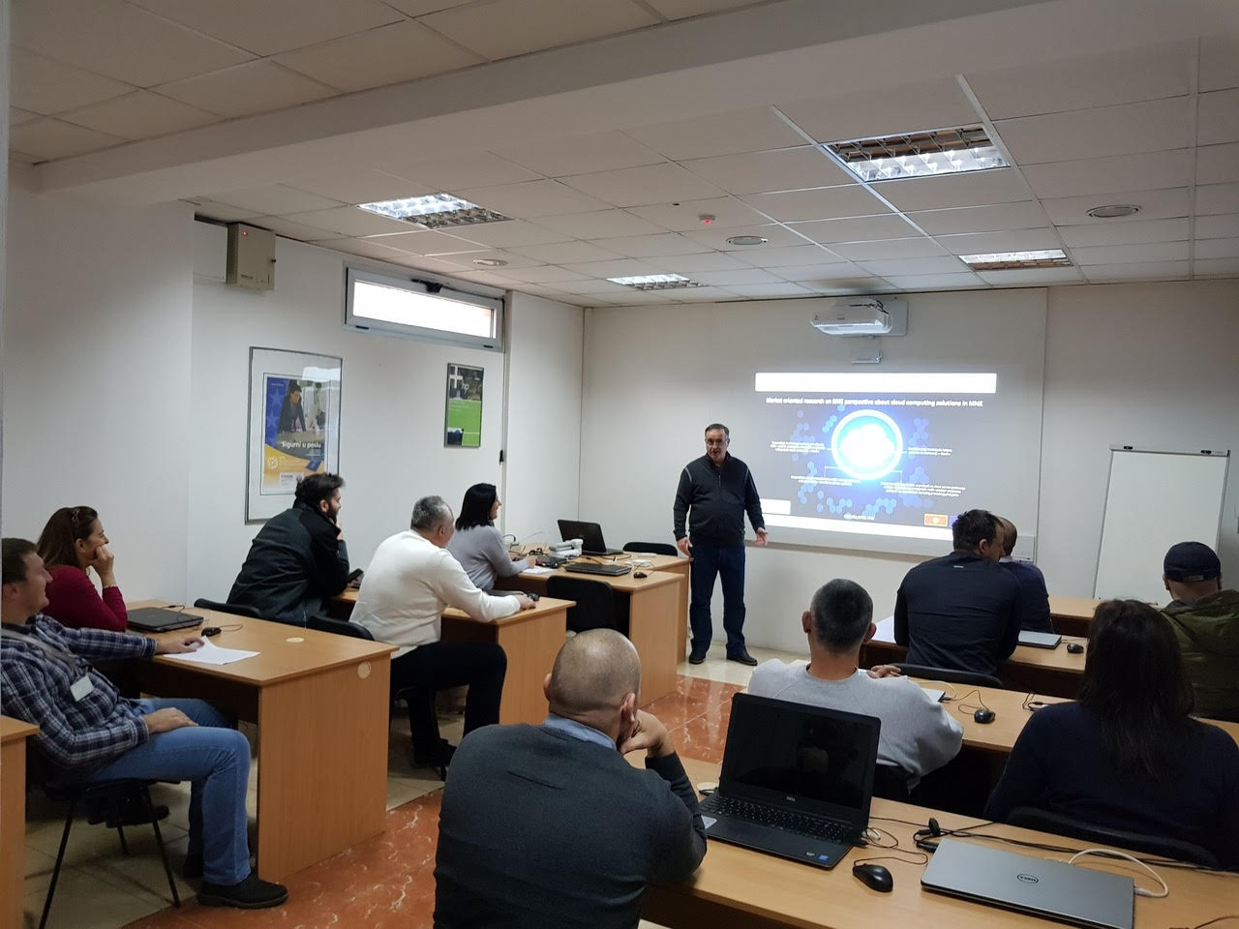
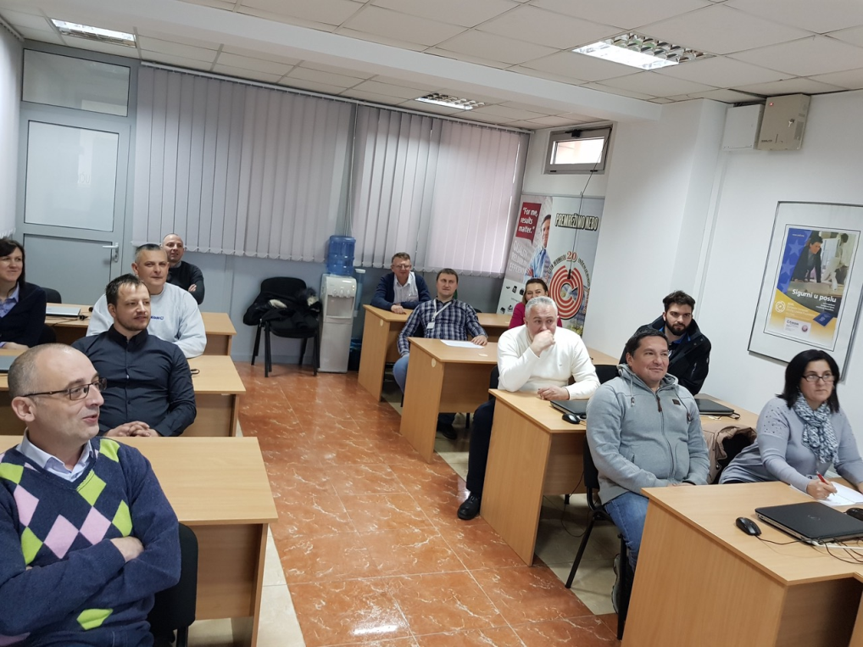

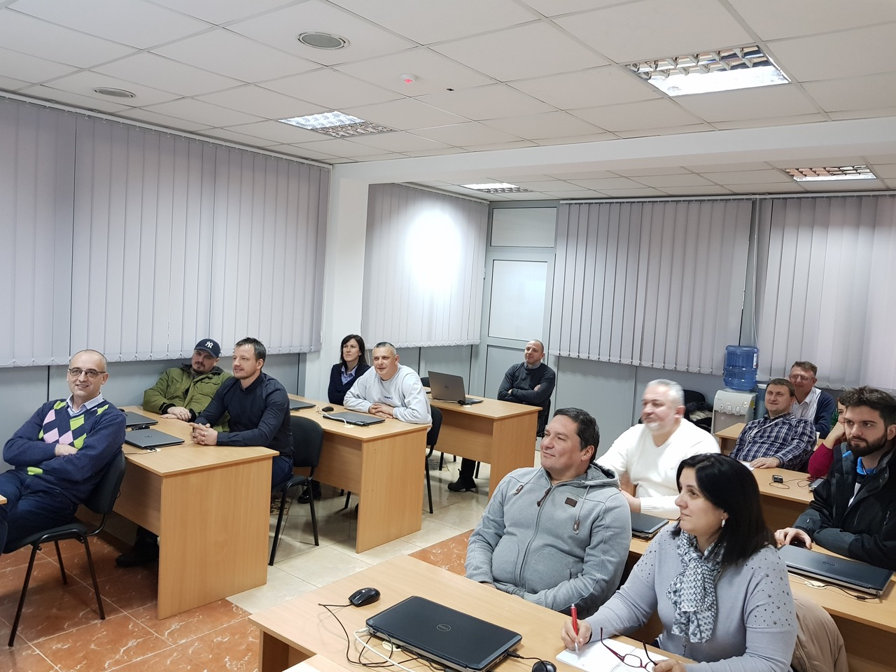
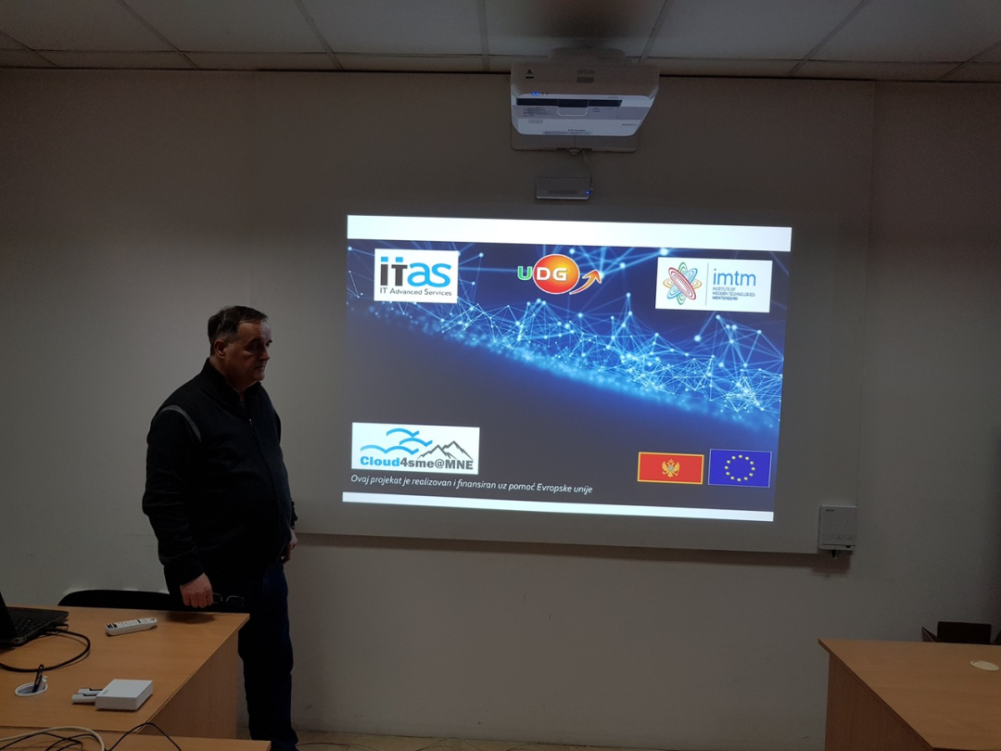

List of participants:
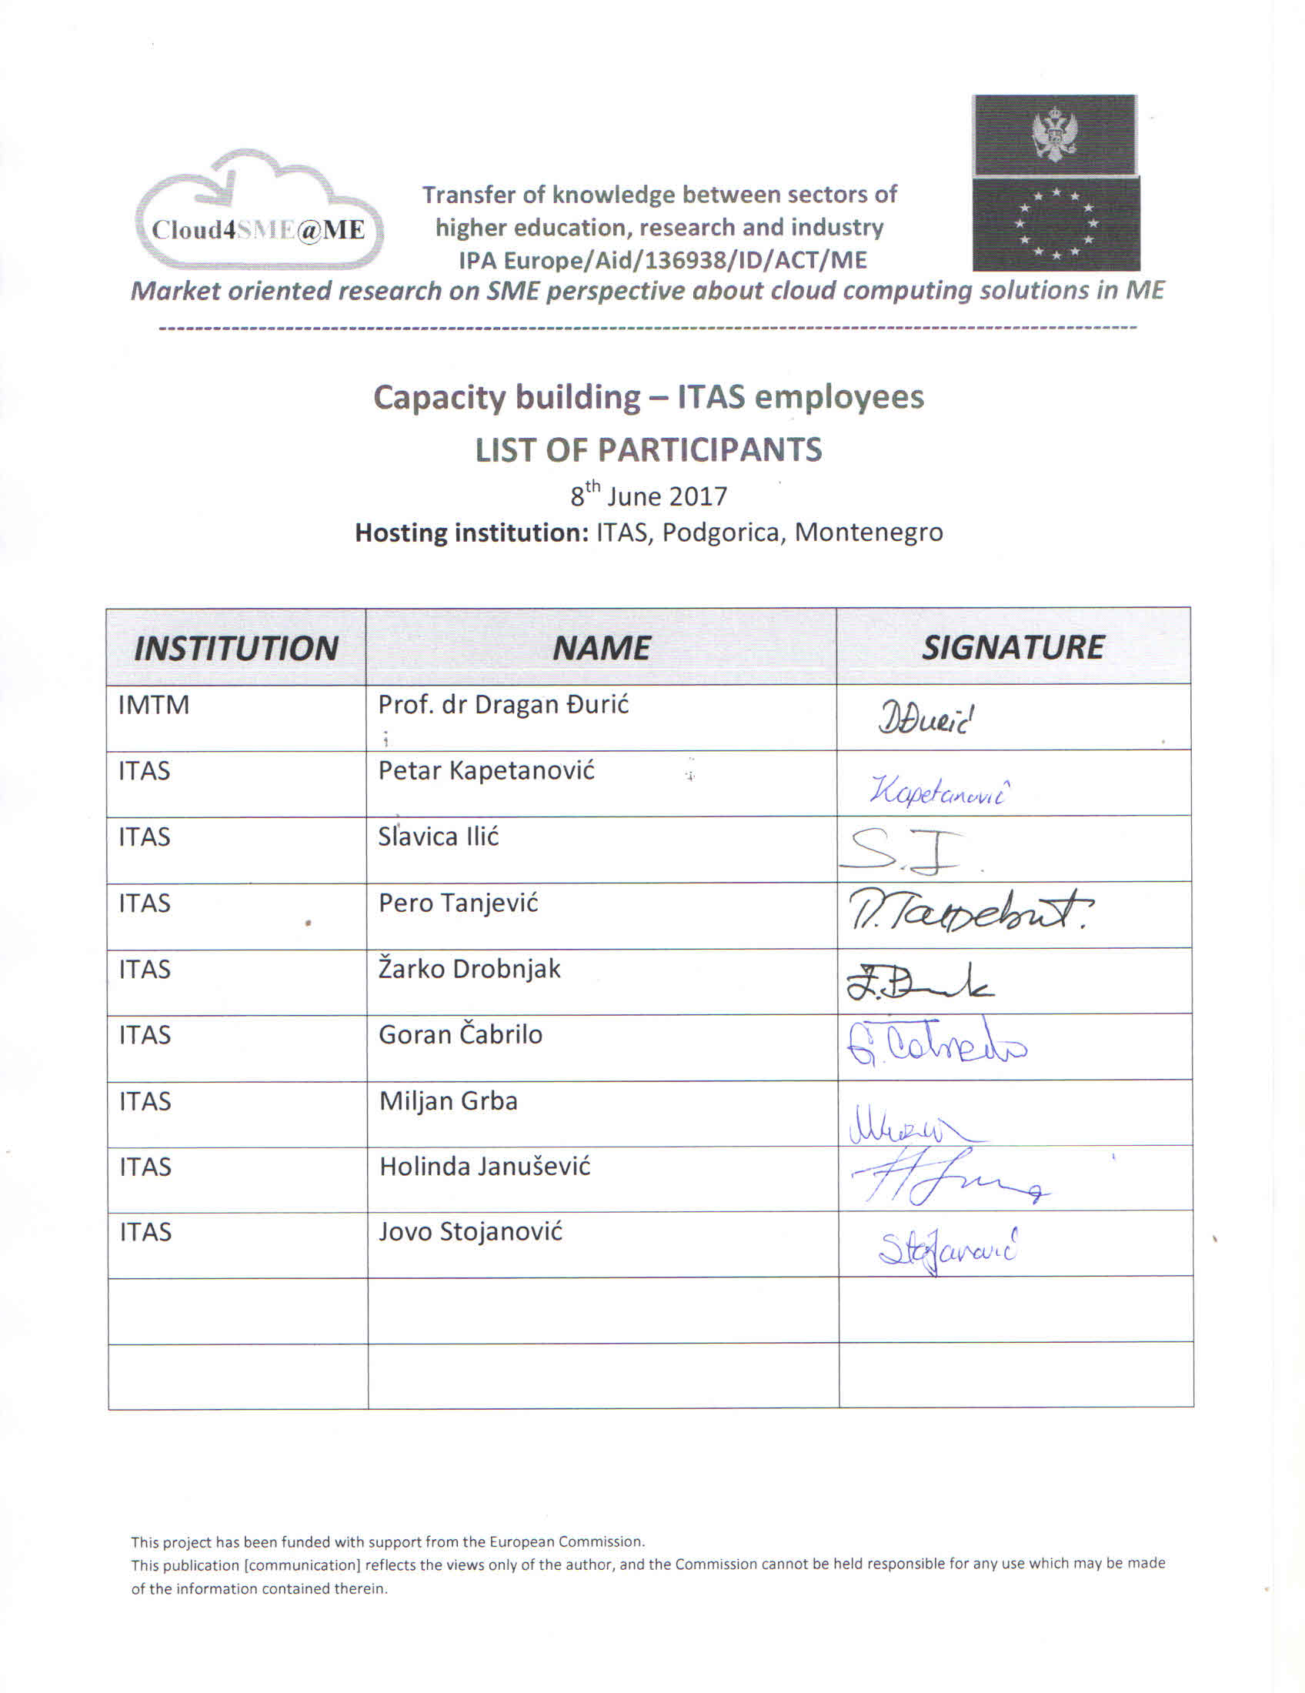
Report prepared by: Dragan Đurić, IMTM

