WP 2–Market oriented research: Cloud perspectives of SMEs in Montenegro

DEV 2.3–Market oriented research: Results analyses and discussions

Table of Contents
1. Introduction 3
2. Survey results 4
3. Discussion: Key findings and suggestions 13

Introduction

This document is created to present key results of market-oriented research conducted over 105 SMEs in Montenegro. The results are also available in Montenegrin language on project web site: http://cloud4sme.me/ipa-survey-reports as presented for each question within each section separately. Furthermore, the survey results are presented at different dissemination events and also accepted for publishing at upcoming Official Gazette by Chamber of Economy Montenegro (see http://cloud4sme.me/activities/dissemination-and-sustainability).
However, the aim of this document is to provide critical overview on identified factors that are essential to be considered and improved at national level in Montenegro, on which bases WP3 of this project will be implemented, as well as further sustainable actions defined.
The Document is organised as follows: Section 2 presents key results from the survey analyses (organised in the form of key 10 conclusions), while Section 4 outlines key suggestions and recommendations.

Survey results
Conclusion 1: The comuters are used in 99% SMEs.
On the question about using computers in their regular business, 99% of survayed companies answered that they used computers. It indicates that Montenegrin companies/SMEs are computerezed and using basic ICT benefits.

Conclusion 2: 80% of SMEs employs ICT experts
The need for employment of ICT experts has 75% SMEs, but it is interesting that 80% of them employ ICT experts (within company or as external expert). 54% of SMEs provide trainings and special courses to the ICT engaged staff, in order to keep human resources updated.

Conclusion 3: 99% of SMEs has Internet access in their premises
The importance of Internet using is recognized within 99% of SMEs, and there are Internet access in their premises.

Conclusion 4: The avarage Internet speed in SMEs is at appropriate level

More than half of SMEs has average Internet speed between 10 and 100 MB/s, i.e. from 10 to 30 MB/s has 36% of SMEs, while the connection speed between 30 and 100 MB/s has 32% of SMEs. The speed less than 2 MB/s has only 1% of SMEs, and the maximized speed – over the 100 MB/s has 10% of SMEs. 21% of SMEs has Internet speed from 2 to 10 MB/s.

Conclusion 5: The level of readiness of SMEs managamant for ICT innovation is high
The managemant of SMEs is awared about importance and benefits of ICT innovation, so 84% of them answered that they are interested for implementation of new, innovative ICT solutions in the companies.

Conclusion 6: Management of SMEs must be more awared about cyber security
The strategy and policy for information security of business information systems (software), as well as for hardwares, has established in only one half of SMEs. The lack of managemant knowladge about cyber security must be minimized.

Conclusion 7: The knowladge of SMEs managemant about cloud computing must be improved
The 11% of managers in SMEs do not know what is cloud computing. The awareness and knowledge about cloud services must be imbroved, so it is necessary to continiue with cloud services promotion.

Conclusion 8: In Montenegrin SMEs the need for using hardware cloud services is more popular than the need of using software cloud services
18% of SMEs has need to use some hardware infrastructure in cloud (applicative server, VM, backup server, etc.), while 25% of SMEs are interested in using cloud hardware infrastructure in combination with some online platforms. Just 15% of SMEs has need for using software solutions based on cloud.

Conclusion 9: Private cloud is the most appropiate solutions for SMEs
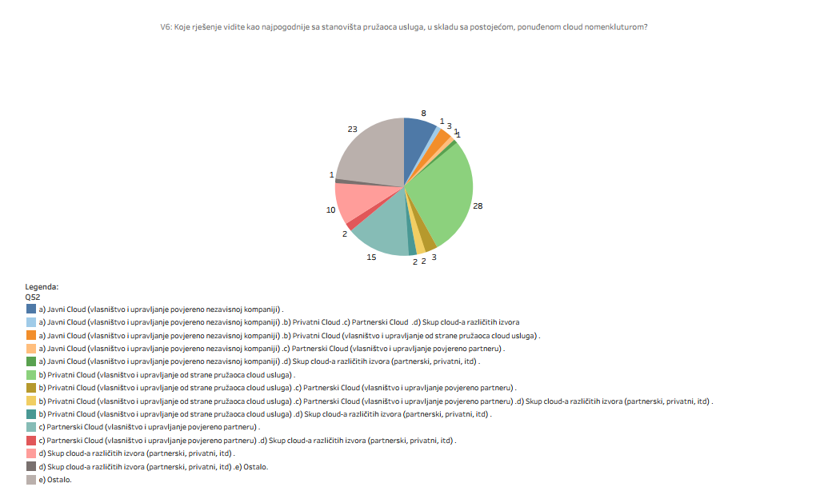
28% of SMEs consider that private cloud is the most appropriate for their business. Public cloud would be decided by 8% of SMEs, and 15% for partners clouud services. The other SMEs will choose some combination of above mentioned three cloud types.

Conclusion 10: Privacy of companies’ data and information is one of the limited factors for using cloud services.
As one of the top limited factors for using cloud computing services in SMEs, the privacy of SMEs’ information is recognized in 60% of surveyed SMEs. The 29% od SMEs consider that the data privacy is important limited factor, while 7% think that is the medium important factor for cloud services. Only 4% of SMEs consider the privacy of data as unimportant factor.

Discussion: Key findings and suggestions

The presented data can be considered as very important resource for understanding existing situation in Montenegro at SME level, and from the perspective of Cloud4SME@ME project, the following key factors can be identified as critical for SMEs when considering moving towards development and use of cloud based solutions in their businesses:
- data privacy
The issue of data privacy is the most important challenge reported even at EU and global level. It’s evident that security is different in the cloud, but it’s also evident that the best cloud providers have much stronger security practices than you can implement in-house at a reasonable cost. They’ve made the investments to provide infrastructure, tools, and processes that give them the highest levels of security and privacy certifications.

Suggestion: Raise awareness about existing solutions that provide data encryption on the move and at rest. Look for, and properly implement, robust identity and access management systems. Always use multifactor authentication. Put good processes in place for key management.

- data security
One of the major challenges is translating SME’s security posture to the cloud environment. Companies can’t assume the cloud provider will handle all security aspects over the data.
Furthermore, most current systems, particularly systems of record (the backbone of an organization's operations) are not cloud-ready. The biggest challenge is to connect legacy systems with newer cloud-based business applications.
Suggestion: When migrating to the cloud, companies should obtain third-party reports, that attest to the security of the cloud organization. Furthermore, it is necessary to connect legacy systems with newer cloud-based business applications.For the short-term to mid-term plans, solutions that can operate in a hybrid environment are essential, along with services from vendors that can support a company’s migration to the cloud.
- service availability
Issues arise when the migration team wants to re-architect the entire infrastructure to perfectly fit offered cloud services, or when the team doesn't want to make a single change. It is beneficial to take advantage of cloud services or scale/cost savings, but not if a rewrite breaks the bank.
Suggestion: The first step can be defined as: get to the cloud as quickly as possible and then start modifying the architecture over time. In the process of choosing appropriate architecture, availability of services shall be analysed and addressed.
- organisational readiness for technological advancements
The same as any big IT project, the biggest challenge is often the change in management. The SMEs need to be sure to help your organization through the change, that the requirements obtained throughout the migration are real and that they have actionable results across your entire business.
Suggestion: Raising awareness among decision makers and authorities is essential!
- awareness level of cloud functioning
Lack of knowledge about key foundations of cloud computing are essential in order to use new services and solutions on the appropriate way. It is also related to identified factors about security issues since only highly educated and highly aware employees about cyber security issues can be considered as cloud users appropriate for the company.

Suggestion: Make systematic planning of raising awareness activities also adopted to the needs of the company, business activities as well as to the level of existing knowledge about cloud computing and Internet services in general.

- existing knowledge and willingness to learn about working with new technologies
When the company is moving step forward and accepts cloud based solutions, it is essential to develop own technical capacities capable to (i) monitor the use of cloud services, and (ii) maintain the services and products.

Suggestion: The company shall express willingness and allocate financial resources to support capacity building activities of employees responsible for technical maintaining and support.

