Dissemination event- Report

Organising institution: University of Donja Gorica

Venue: Erasmus+ credit mobility project meeting
Place: Cloud Research Lab., Furtwangen University, Germany
Date: 10/04/2017

Narrative report
UDG representatives, Prof. dr Ramo Šendelj and Assist. Prof. Ivana Ognjanović, together with the project external expert Igor Ognjanović, visited Cloud Research Lab. at Furtwangen University in Germany. They used opportunity to introduce Cloud4sme@MNE project to the research community at international level.
The Clour Research Lab. representatives shared their own experience about developing cloud based solutions in Germany, and gave some recommendations about questionnaire, as well as for developing the best cloud services in Montenegro.

Photos:
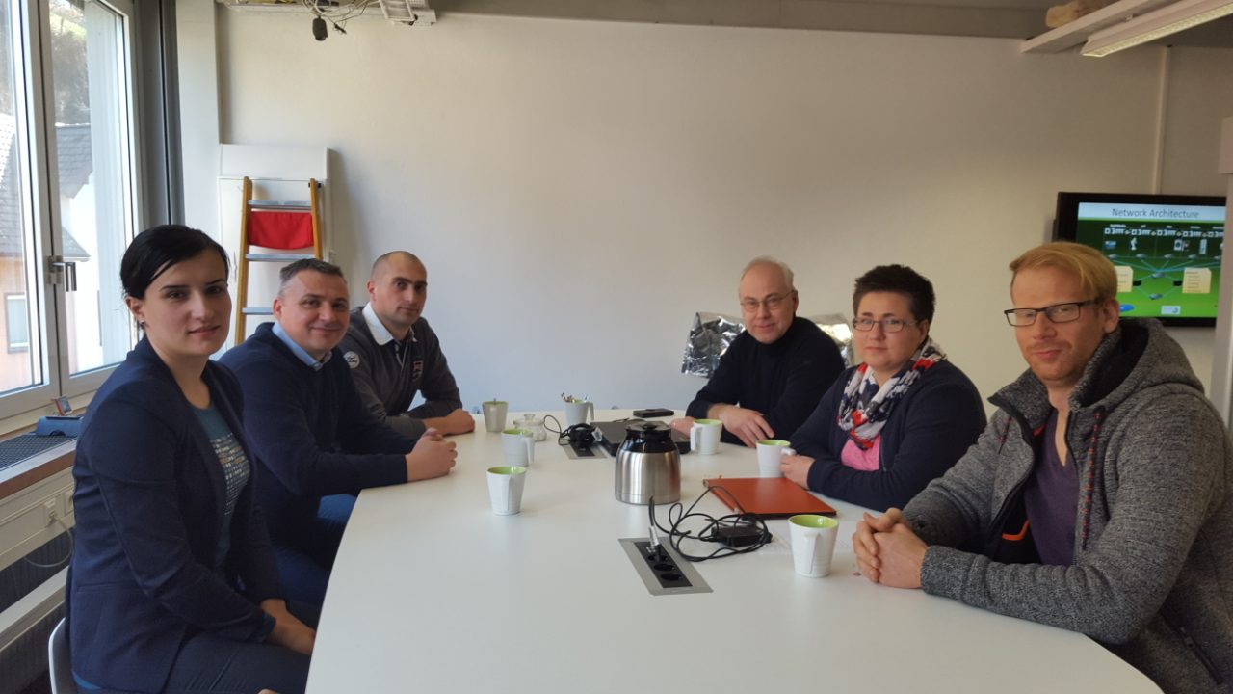
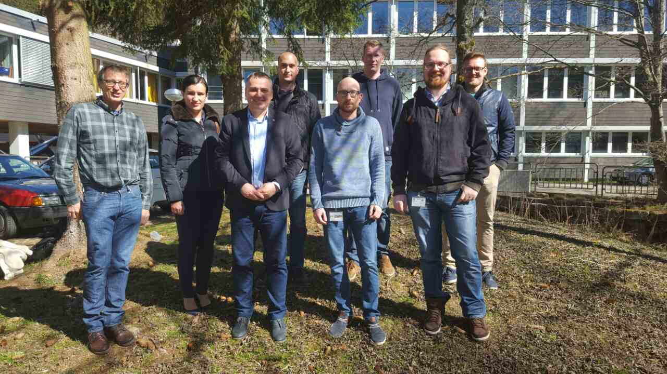
Report prepared by: Assist. Prof. Ivana Ognjanovic, UDG

