# Dissemination event- Report

**Organising institution:** IT Advance services ltd

**Venue:** Conference “Integrated cyber defense in the cloud generation“

**Place:** Best Western Premier Hotel,Podgorica, Montenegro

**Date:** 29/11/2017

**Narrative report**

ITAS ltd, together with Čikom ltd and worldwide recognized company for security of information systems – Symantec, organised conference “Integrated cyber defence in the cloud generation”, held on 29th November 2017 at best Western Premier Hotel.

The Conference had topics about Power of Proxy, Data Loss Prevention, Information centric security, and the most important topics in collaboration with project were: Cyber defence in cloud generation, and Endpoint Security for cloud generation.

The executive director, Mr. Petar Kapetanovic introduced audience with Cloud4sme@MNE outputs and survey results about using ICT and cloud in Montenegrin SMEs.

**Photos:**



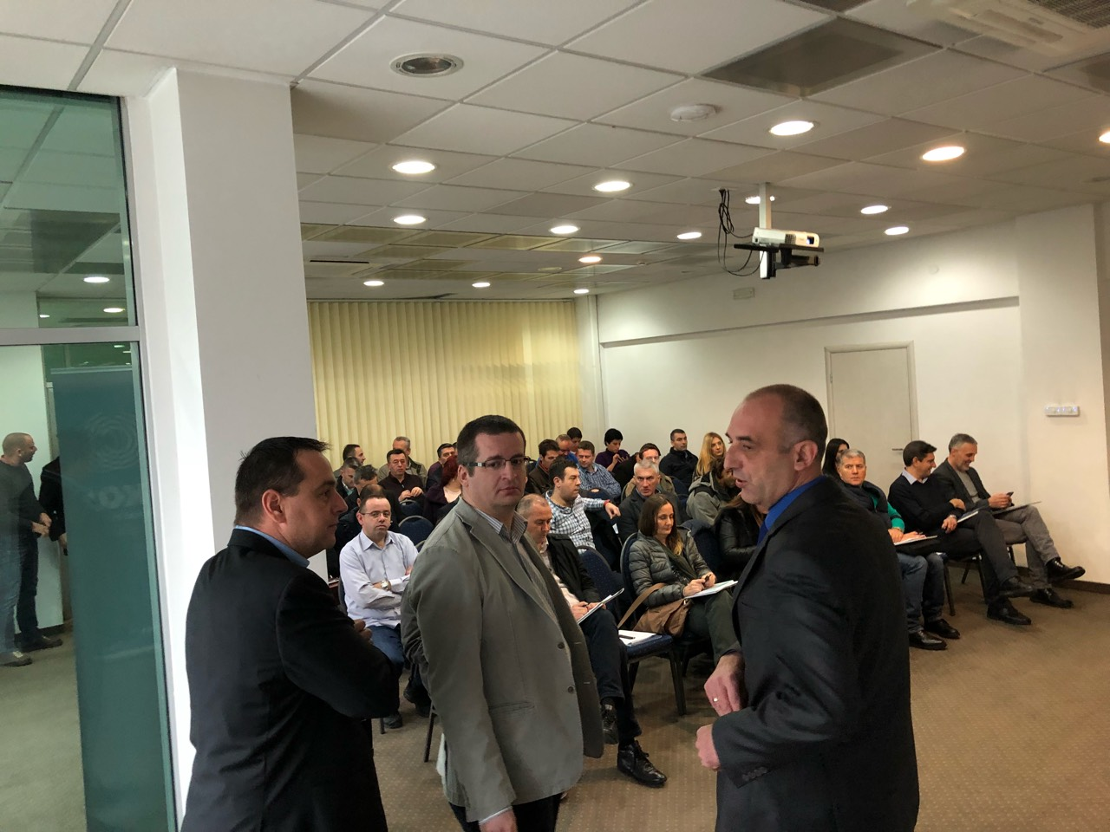

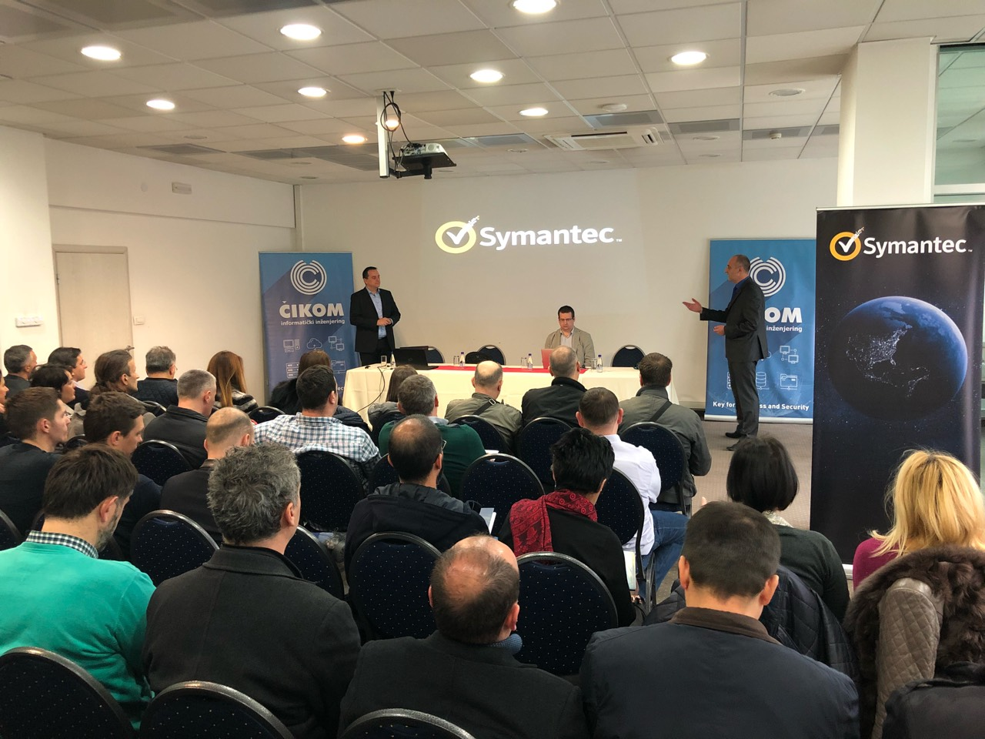

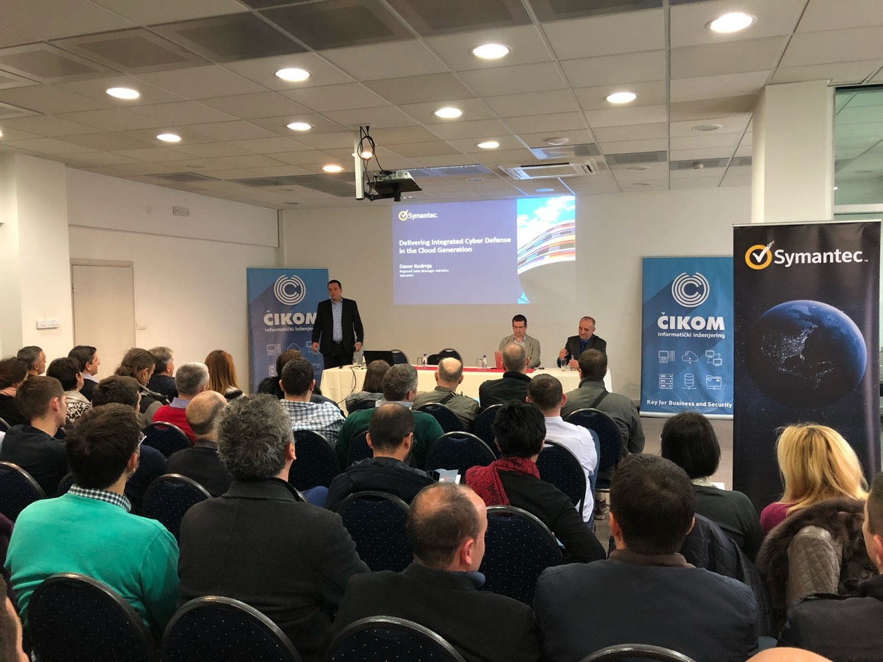

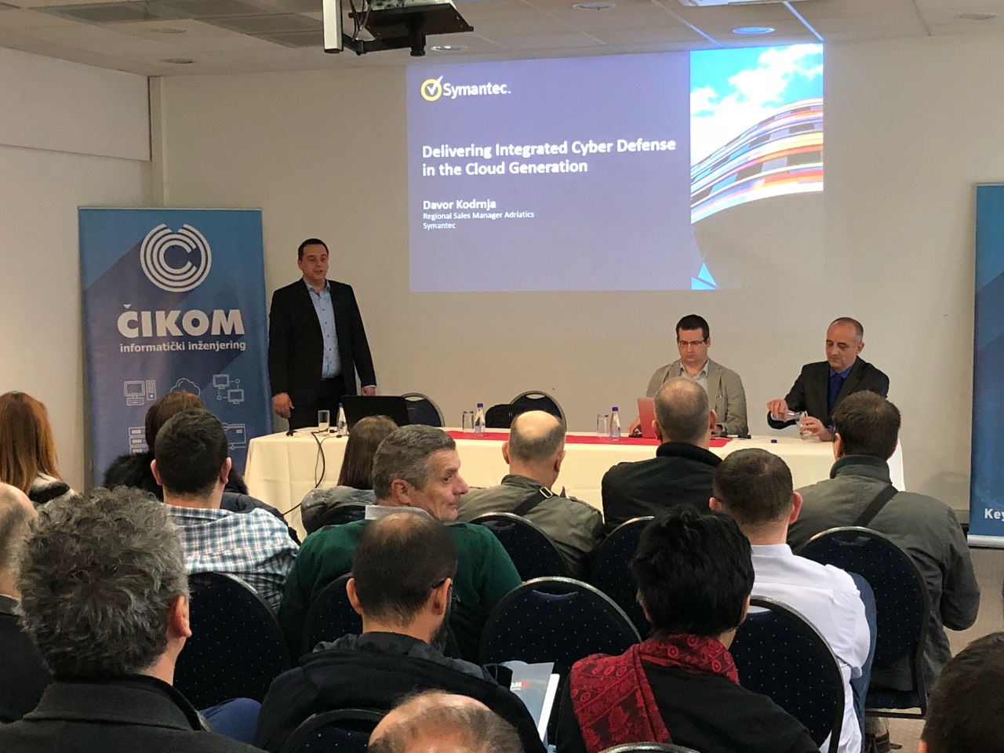

**Report prepared by: Milica Gogic, ITAS**