Raising awareness activity - Report
“Rittal Cloud Day”

1. AGENDA
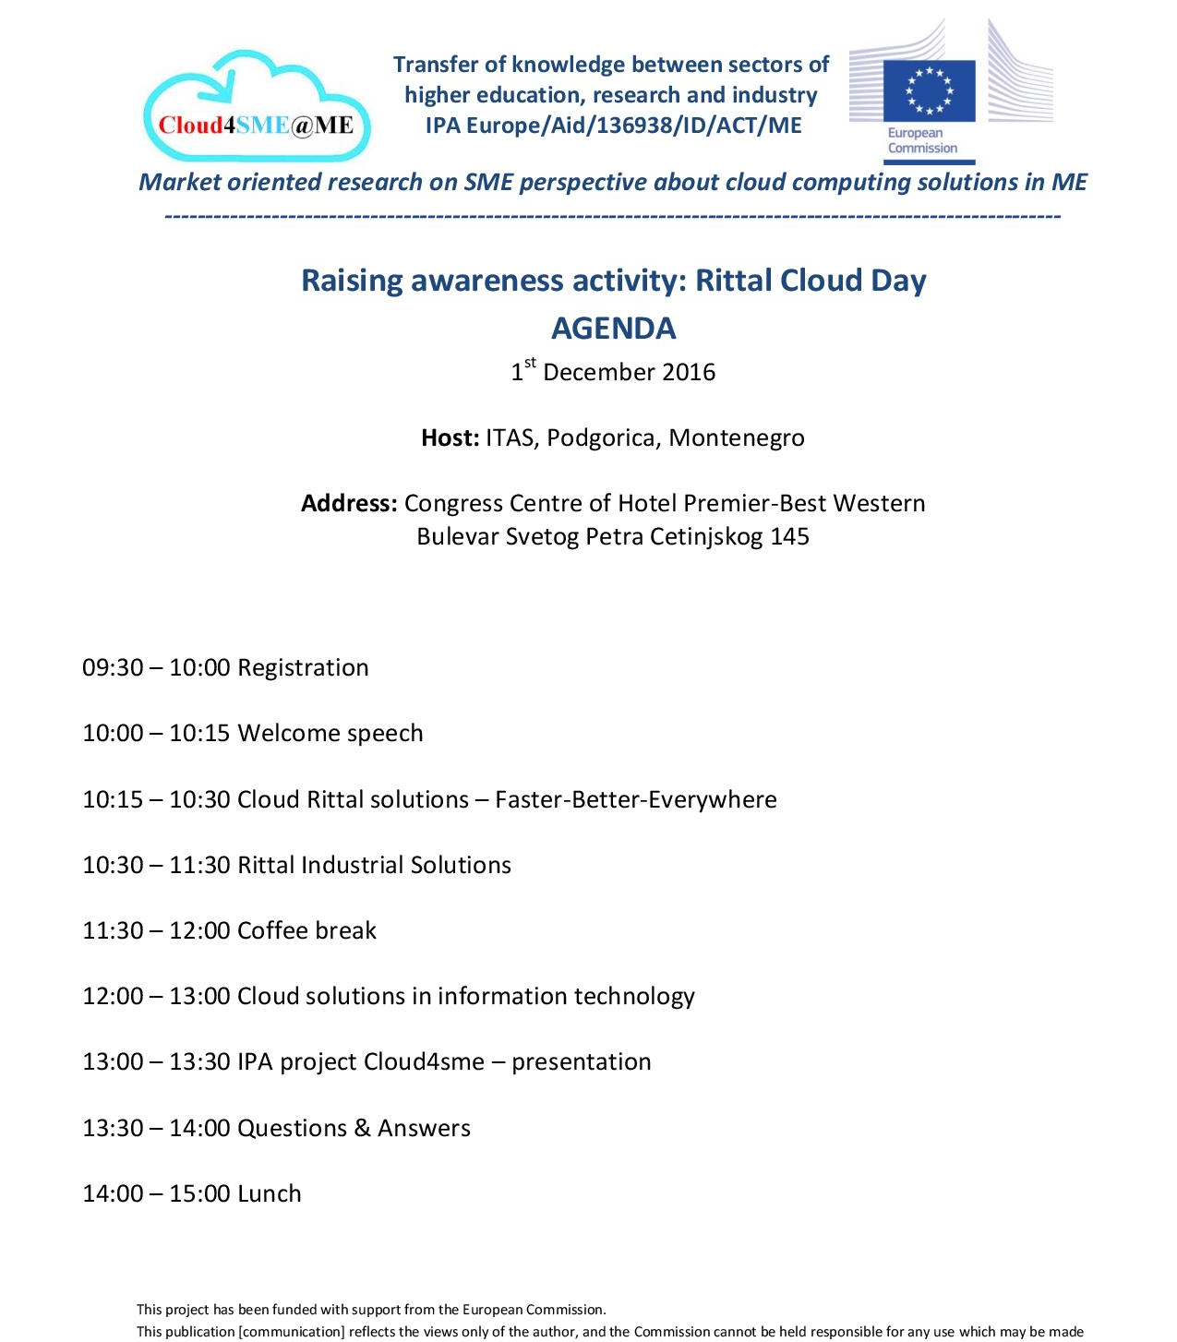

2. NARRATIVE REPORT

Cikom ltd Podgorica, the company in close relation with IT Advanced Services, together with business partner company Rittal on 1st December organized Rittal Cloud Day, at Congress Centre of Hotel Premier-Best Western in Podgorica. The event was organized with main aim to promote the cloud services among Montenegrin citizens, i.e. representatives of MNE SMEs.

Total number of participants at the Rittal Cloud Day was 75.

General Manager of Cikom ltd, Mr Vladan Tabas, welcomed all participants and summarized what will be done at the event. After his introduction, Mr Dokmanović presented the current situation about using cloud services and cloud operations in business sector in the region and Montenegro, and make some cross matching.

The next topic was focused on implementation of cloud services in industry, and there was presented the best solutions for including cloud in hydropower plants, wind power plants, electrical power plants, process industry, food industry and civil and transport industry. Also, the potential problems that can be faced during cloud implementation were presented, as well as the resolving process.

The event was followed by discussion about information technology and clouds, with highlight on ICT risks, critical infrastructure, security standards, legal regulations in Montenegro in the area of cloud services, review of Cloud IT solutions and Cloud solutions of Data Centres, with practical examples in governmental bodies, bank industry, insurance companies, retail and energetic.

The last session was reserved for presentation of objectives, activities and estimated results of IPA project “Market oriented research on SME perspective about cloud computing solutions in MNE” – Cloud4SME@ME. The participants are introduced with expected results and how they can benefit from it.
3. PHOTOS

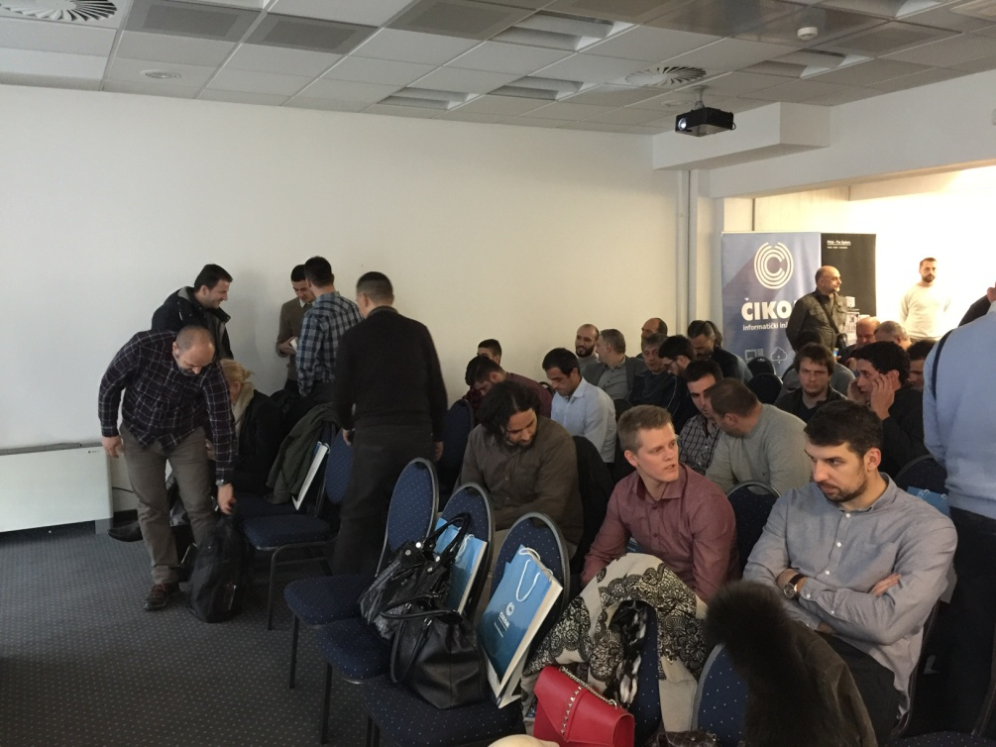
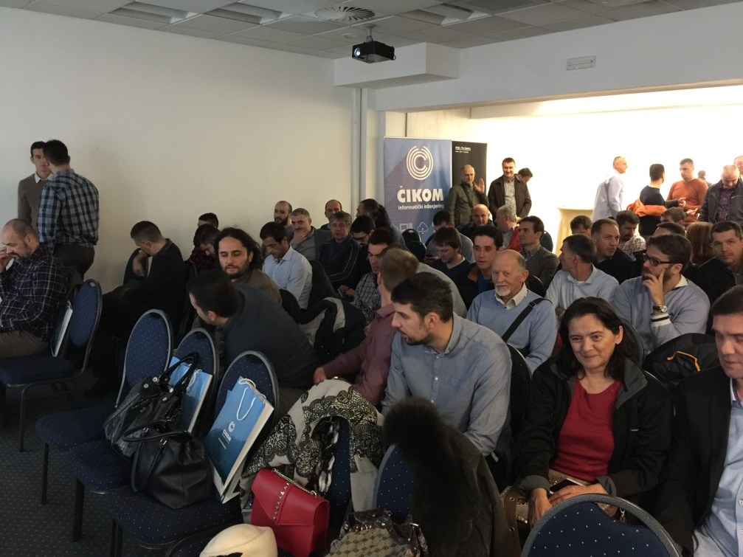
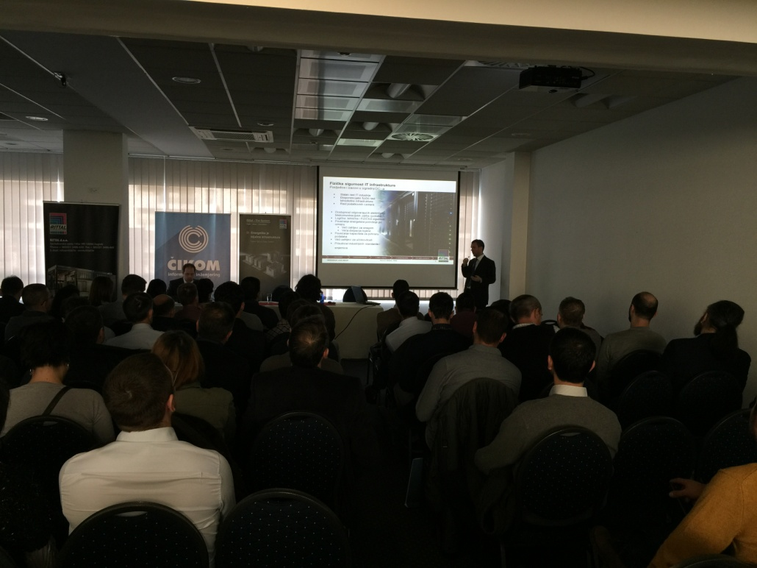
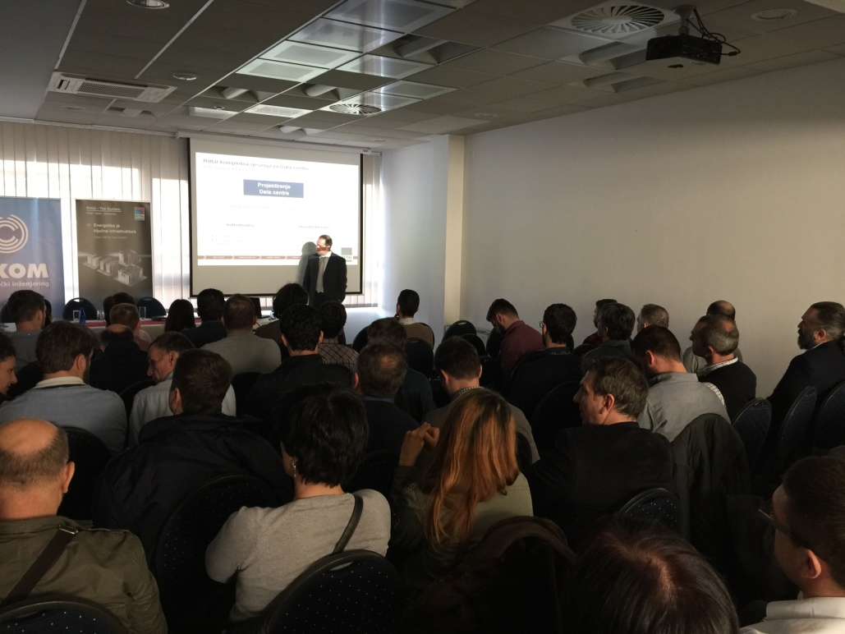

4. LIST OF PARTICIPANTS

